**AWS**

**(Amazon web services)**

AWS is one of the leading cloud computing service providers. AWS has around 230+ services.

These services are categorized as:

1. Compute services
2. Storage services
3. Database services
4. Networking services
5. Analytics services
6. Security, Identity and compliance
7. Migration services
8. Management tool Services

**Amazon S3:**

1. Amazon S3 stands for Simple Storage Service.
2. S3 is an object-based storage service which is used to store and retrieve data at any time.
3. S3 doesn’t have any limit to store the data.
4. S3 is the second service launched by AWS in 2006. (SQS is the first service launched in 2004)

**Features of S3:**

**Availability:** S3 maintains 3 copies of data. If one gets crashed then data can be copied from next two copie

**Scalability**: No Storage limit

**Latency**: Data available in SSD(Solid state disk) where data transfer is fast

**Internet**: Data can be accessed from any where via internet.

**Durability**: Data will be present for certain duration in S3 bucket.

**Creation of S3 bucket, uploading and downloading files using AWS management console:**

**Creation of S3 bucket:**

1. Sign-in to AWS account.
2. Search for S3 in aws management console
3. Click on buckets
4. Select the region
5. Click on Create Bucket
6. Enter the bucket name ( this must be unique globally)
7. Block all the public access for the bucket (if you are not hoisting any static website)
8. Disable bucket versioning
9. Click on create bucket.

Now your bucket is created.

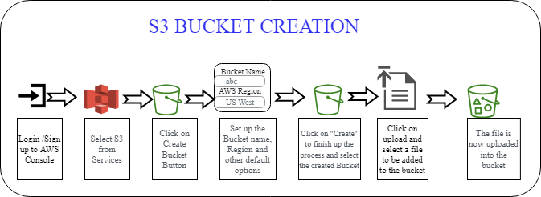

**Uploading files in S3 bucket:**

1. Click on bucket
2. Click on upload button
3. Add files and folders using drag and drop or you can click on add files, folders.
4. You can also create a folder to store data where folder name can be similar but the bucket name should be unique.

**Downloading files from S3 bucket:**

1. Enter into s3 bucket
2. Select the file which we want to download and go to actions
3. Click on download.

**Deleting an S3 bucket:**

To delete an S3 bucket, the bucket must be empty. If you have files in your bucket then you need to delete all those files first, and then you can able to delete that bucket.

1. Enter into S3 bucket
2. Delete all the files which are present in that bucket
3. After delting all the files, you can select that bucket and click on delete.

**Hoisting a static website in S3:**

To host a static website in S3 you don’t need any DNS(domain name service) because Aws generates domain name for S3 bucket which is unique through out globally.

To hoist a static website.

1. Make your bucket as public
2. Files of website needs to be public
3. And the static website hoisting should be enable

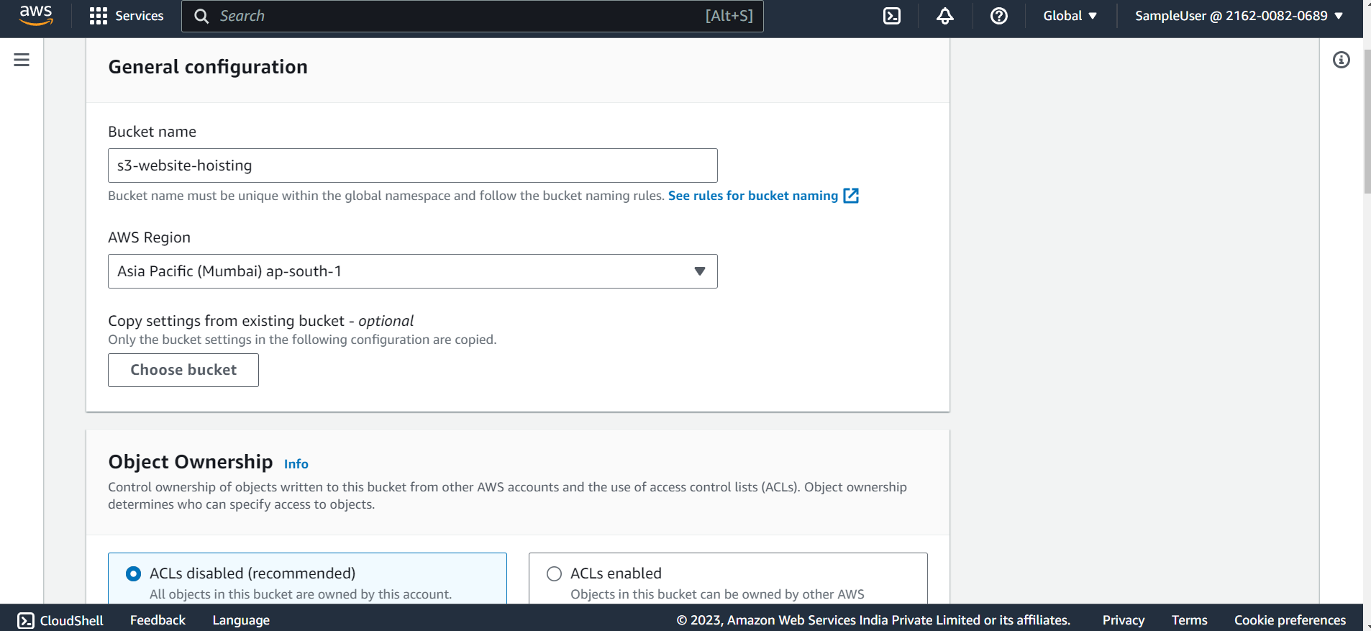

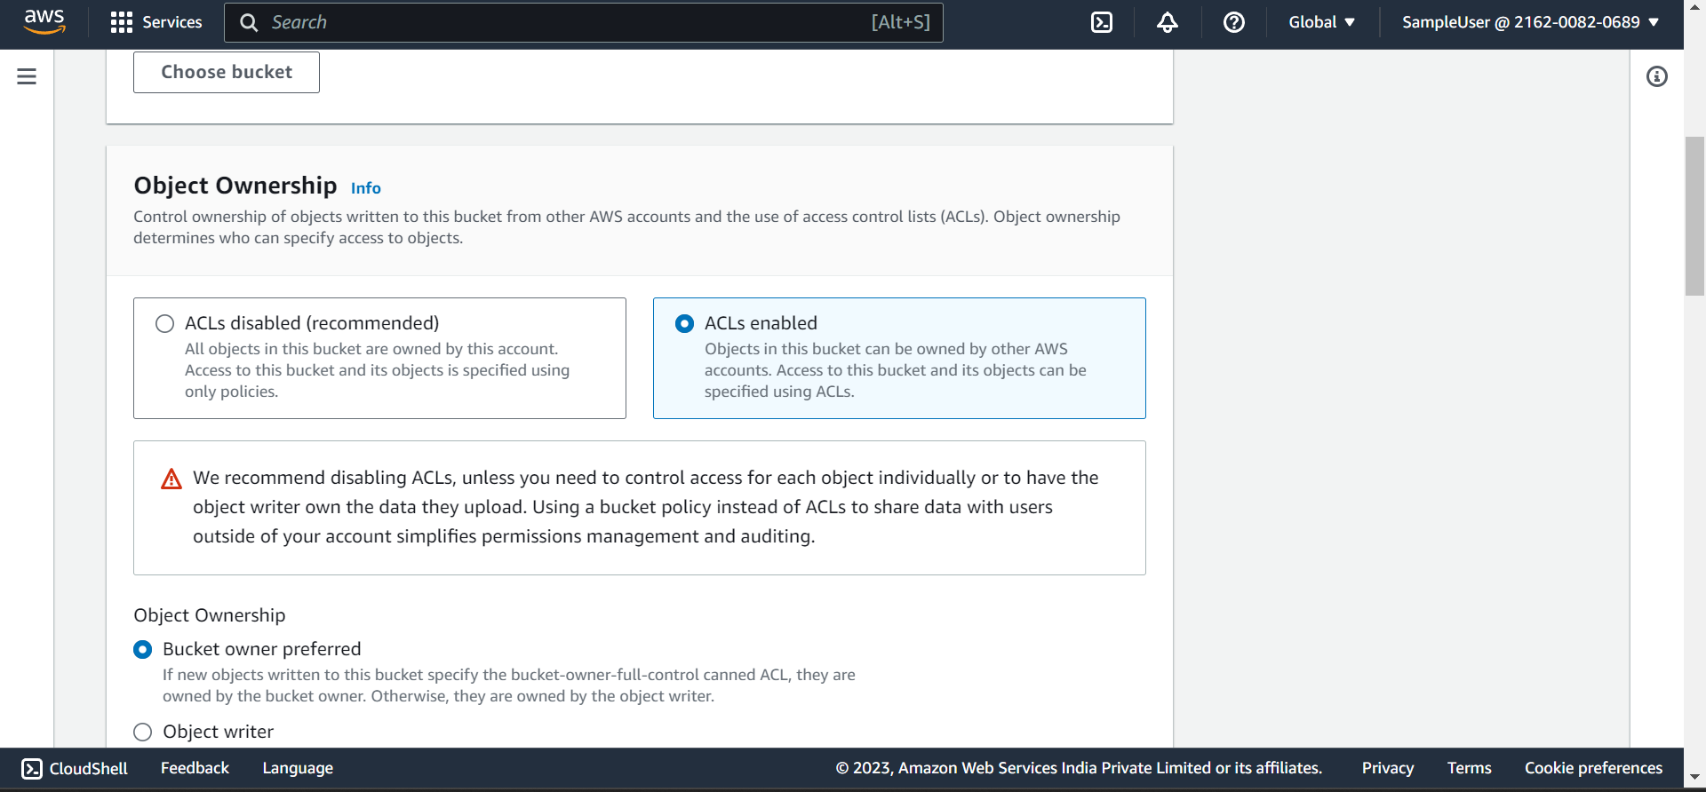

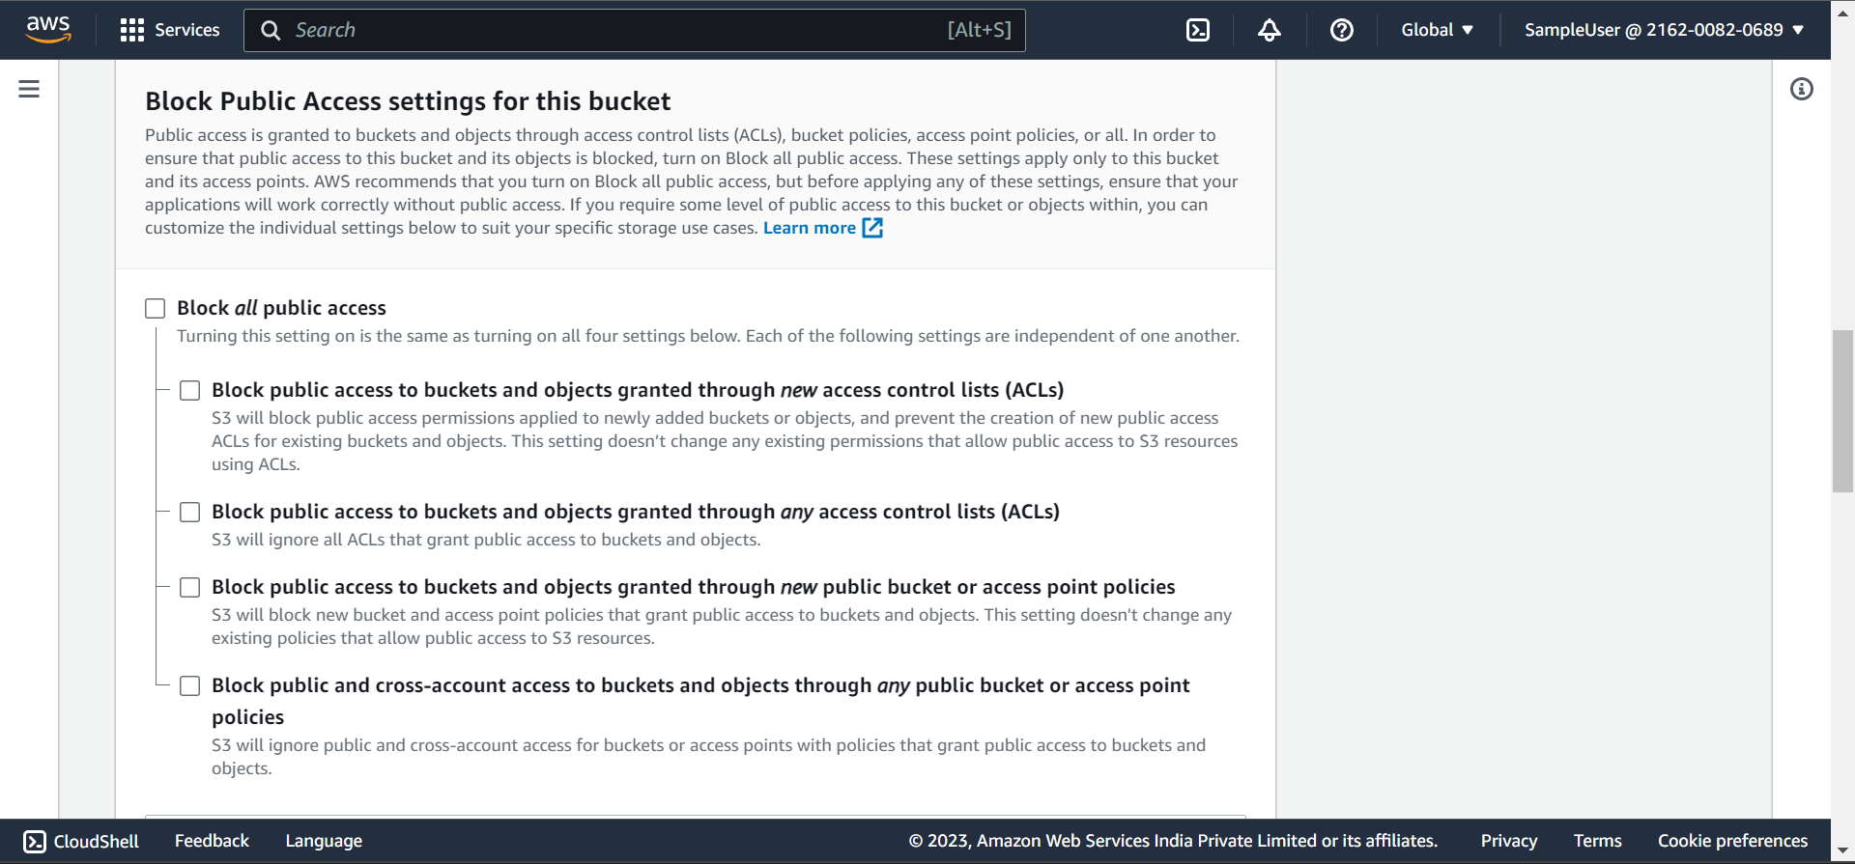

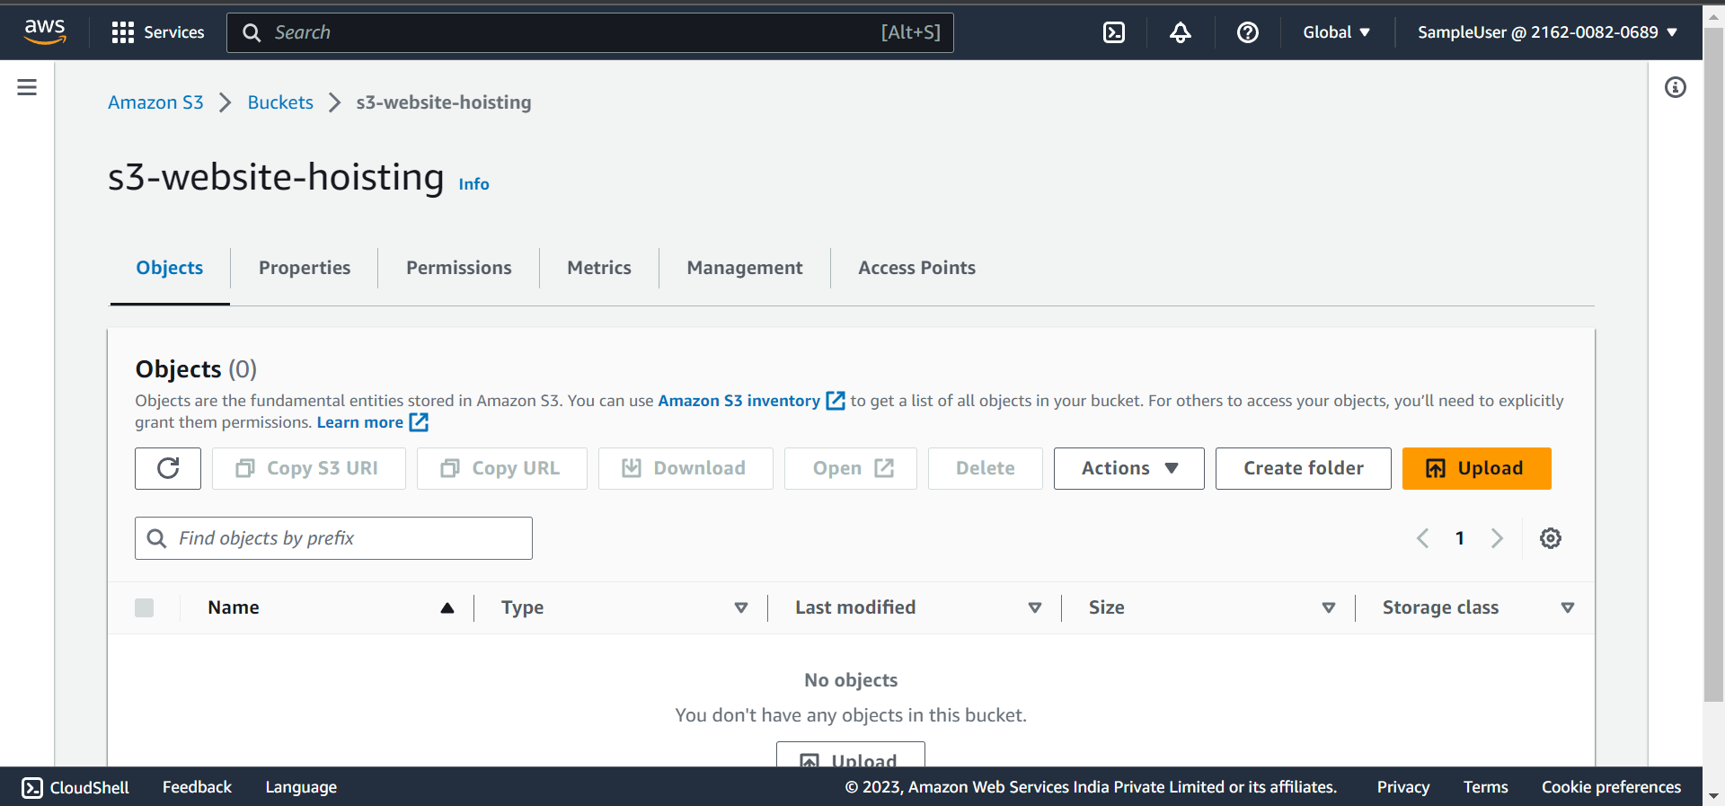

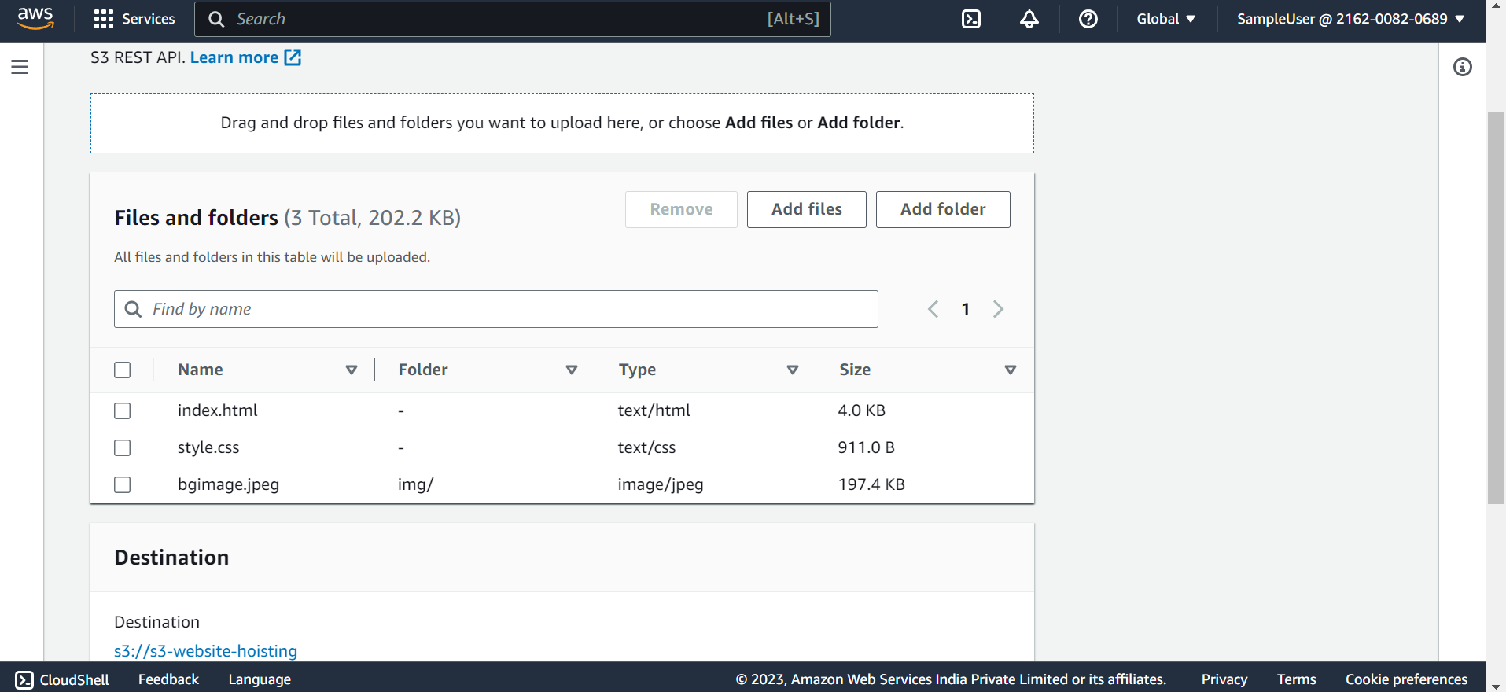

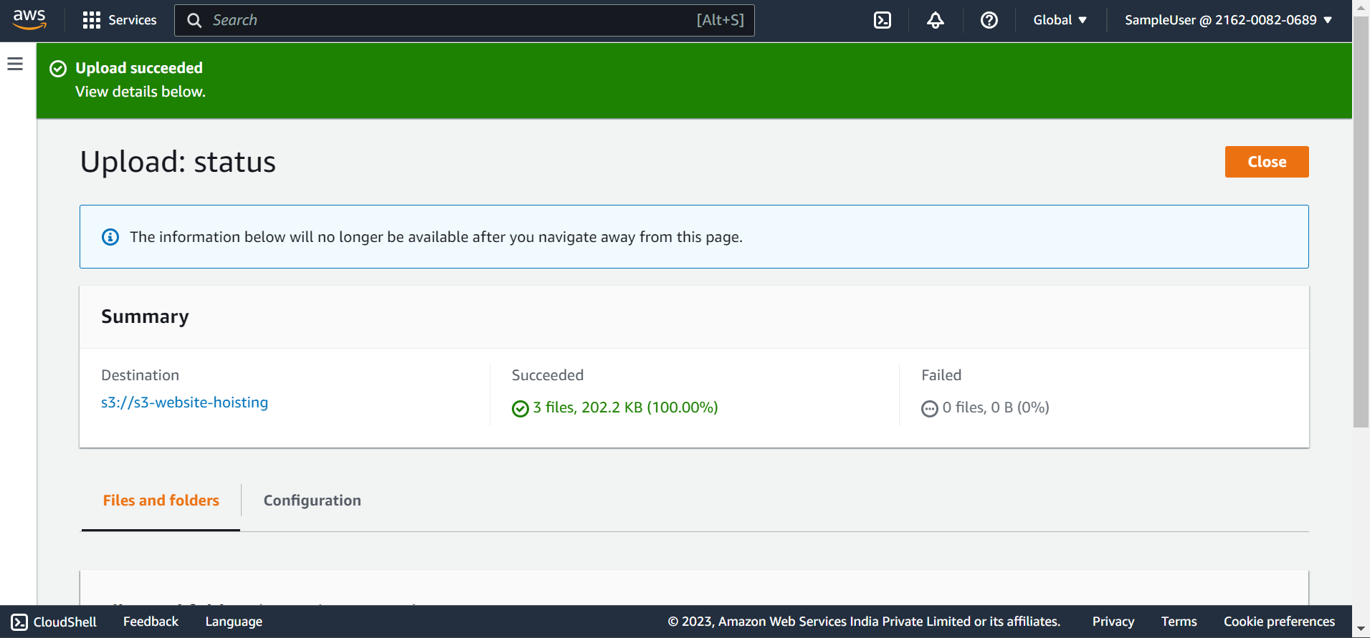

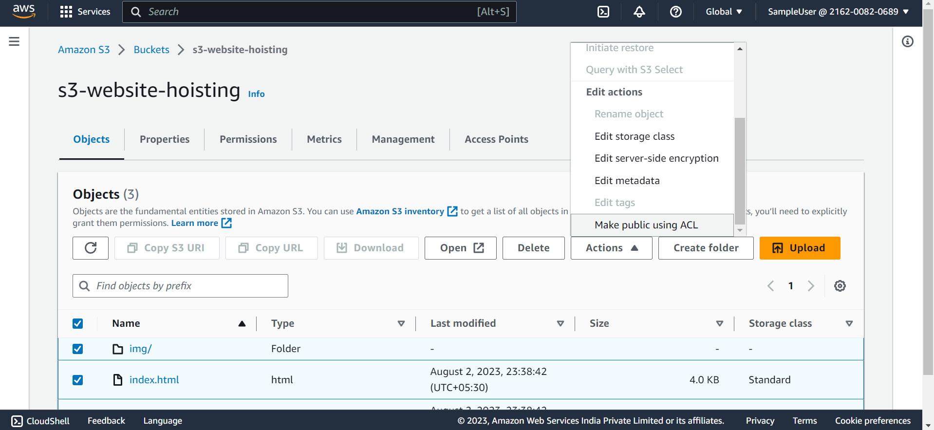

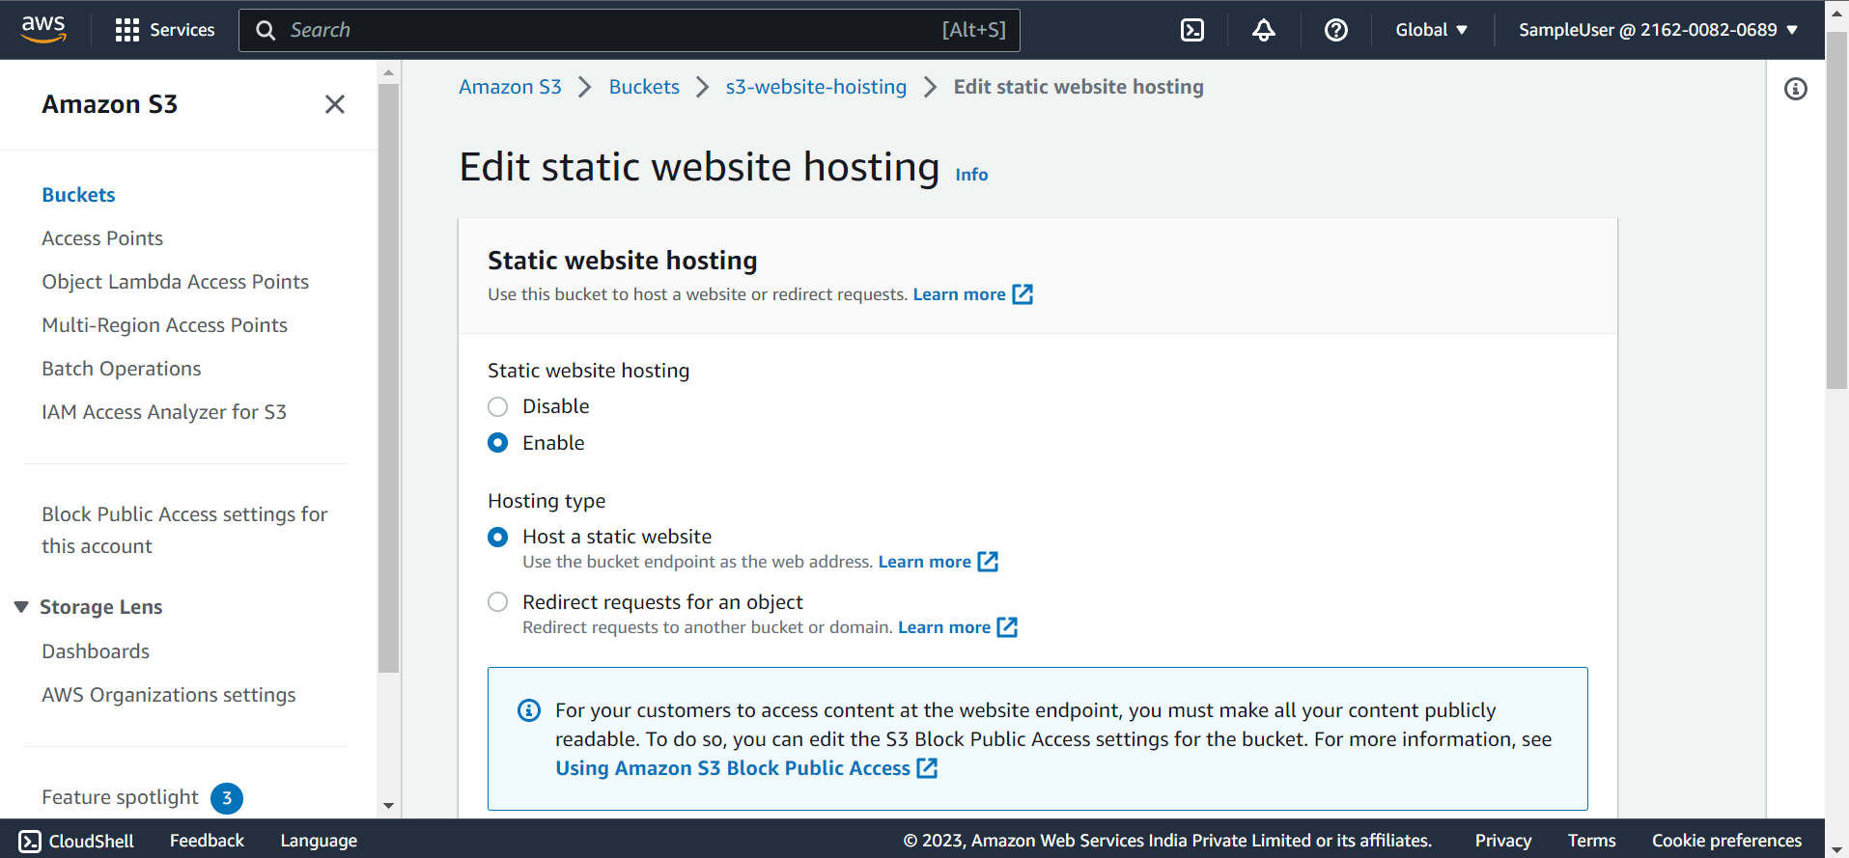

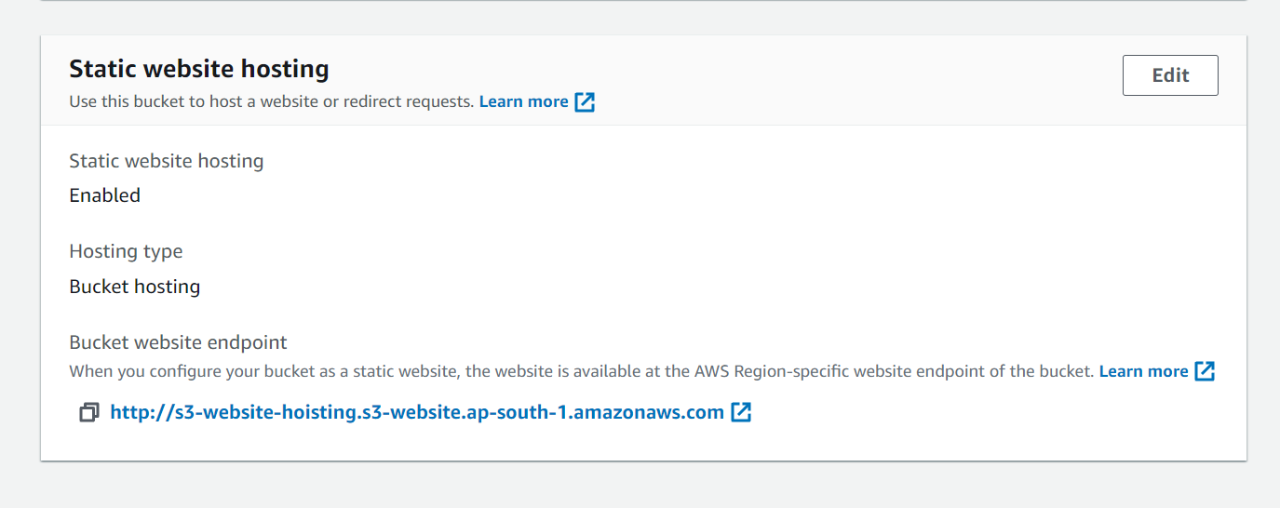

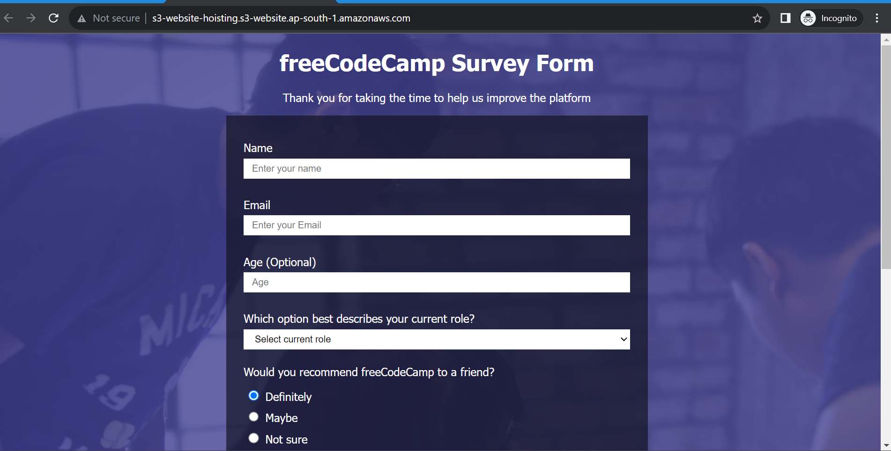

**Storage Classes in S3:**

Storage classes tell how data should be stored like archival or File and how many copies etc.

We mainly have 7 storage classes:

These 7 classes are categorized into 4 categories:

1. Frequently Accessed : Here frequently accessed data is stored
2. Infrequently Accessed: here infrequently accessed data (backup) is stored.
3. Intelligent Tier: Intelligent tier will decide which is frequently accessed data and infrequently accessed data.
4. Archival Storage: Zip format

7 Storage Classes:

1. Standard
2. Reduced Redundant Storage (RRS)
3. Intelligent
4. Standard – IA
5. One Zone – IA
6. Glacier
7. Glacier Deep Archival

Here , Standard and RRS belongs to frequently accessed storage

Standard-IA , One Zone -IA belongs to infrequently accessed storage

Galcier, glacier deep archival belongs to archival (Zip format)

With in the Standard and RRS we can upload , download , copy frequently accessed data.

With in Standard-IA and one-zone-IA we can upload , download, copy infrequently accessed data.

We can use Glacier and glacier deep archival for archival storage.

Intelligent belongs to intellignet tier category where it decides whether data should be stored in frequently accessed or infrequently accessed tier.

**Points to remember while storing data:**

**Storage:**

Standard -> 100mb file

Glacier -> 50 – 70 mb

Glacier deep archival -> 20 mb

This is how a file is stored.

**Cost:**

Standard -> 100 mb file stored in more availablity zones,requires more storage and more cost -> 10$

Glacier -> 50 mb -> 5 $

Galcier deep archival -> 20 mb -> 2$

In Frequently accessed Tier, we have 2 storage classes.

1. Standard
2. RRS

**Standard:** It stores data in minimum 3 copies.

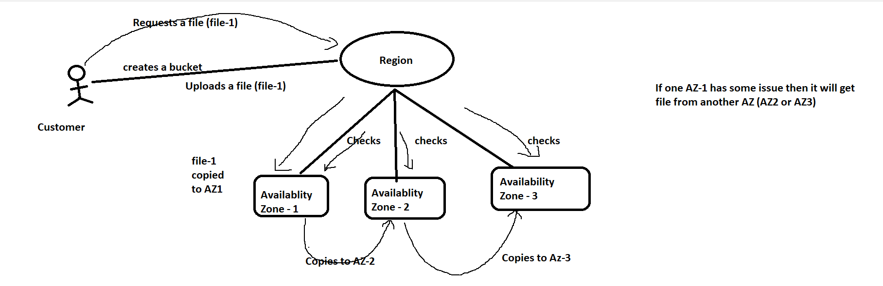

Availablity zones are different locations in a Region.

**RRS (Reduced Redundancy Storage):**

* If you want to store data which is not that much important then you can use RRS.
* If you are storing 100% data for certain years, then around 1.5% of data will be reduced every year.
* Here, you are losing some data, even AWS don’t recommend this RRS.

**Infrequent Accessed:**

1. Standard -IA : Here data stored as same as Standard (mininum of 3 copies)
2. One Zone – IA : stores in only one availability zone. There is no gurantee for our data

**Archival:**

Glacier and Glacier deep archival stores data in minimum 3copies as same as standard and standard – IA

In frequently and infrequently accessed , data is stored in same format.

But in archival, the data is stored in zip format in Glacier and in deep zip in Galcier Deep archival.

**Intelligent Tier:**

Here the data is stored as same as Standard (minimum of 3 copies).

In this intelligent , AWS decides which data is frequently accessed and infrequently accessed on the user usage.

**Pricing in S3:**

**Storage Price:**

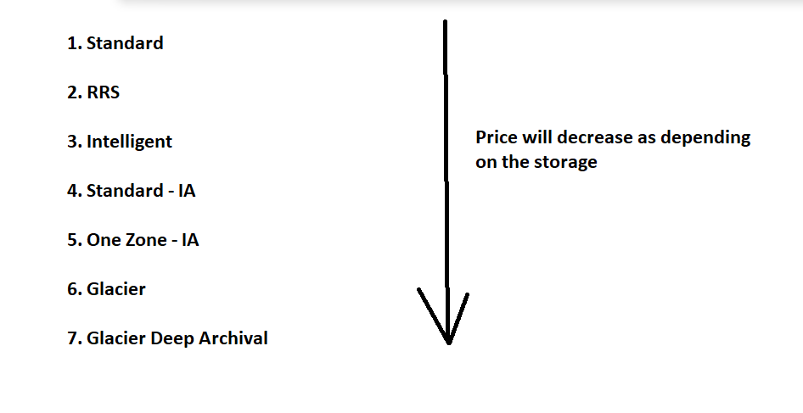

Here the price get decreased depending on the storage. Because the file stored in Standard is different from Glacier and Glacier deep archival.

Standard – 1 GB

Glacier – 3 MB

Glacier Deep archival -1MB

Here standard occupies more storage and glacier and glacier deep archival occupies less storage.Hence the price varies depending on storage

**Download charges (Retrival Fee):**

When we download some files from S3 buckets then there are some retrival charges.

To retrive files from Standard, RRS, Intelligent we don’t have any charges.

To retrieve files from Standard-IA, One zone, Glacier and deep archival we have some retrival charges.

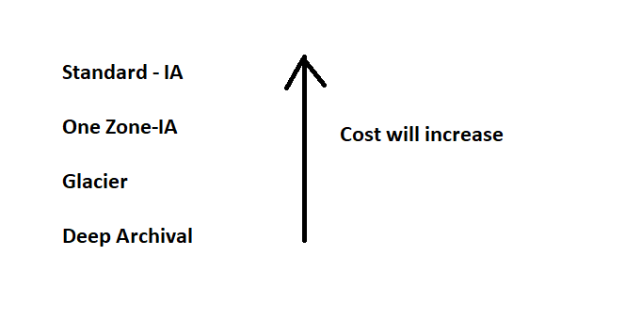

Here, files in standard-IA and one zone can be downloaded immediately

But files in Glacier takes 5 min to 12 hrs of time and glacier deep archival takes 12 hrs which is fixed to download files.

**Minimum charges:**

For standard , RRS, intelligent we have to pay as you go

For standard – IA , One zone we have charges.

Suppose , I uploaded a file in Standard-IA which is a infrequently accessed and I deleted that file immediately then also I will be charged for 28 days.

For glacier the charge is for 90 days.

For deep archival, charge is for 180 days.

If you uploaded a file in deep archival , and delete it in a minute then also you have to pay 180 days storage cose in deep archival.

**EC2 (Elastic Compute Cloud):**

Amazon EC2 is a compute service which is used to create virtual servers or Virtual machines, run applications on cloud.

EC2 provides secure and resizable compute capacity in cloud.It offers Infrastructure as a Service (IAAS).

EC2 provides various types of instances with different configurations of CPU, memory, storage and networking resources depending on the requirement. EC2

You can integrate EC2 with other AWS services like S3, RDS. You can easily scale up and scale down your ec2 instance.

**Creating an EC2 instance:**

**Creating Windows EC2 instance:**

1. Login to AWS console and search for EC2
2. Click on launch instance
3. Enter name of the instance
4. Select amazon machine image (AMI)

AMI is nothing but an OS image.

1. There are different OS images , Amazon linux, MAC OS, Windows etc
2. I’m selecting Windows as my AMI
3. Select Instance type as t2.micro which is a free tier
4. You create or select an existing key pair which is used to securely connect to your instance.

There are two types of private keys.

1. .pem (privacy enhanced mail) file which is used to connect using SSH
2. .ppk (putty private key) file which is used to connect with putty
3. Click on Launch instance.
4. Now your instance is successfully created and running.

Now we need to connect with our instance from our local system.

Since we have created windows EC2 instance, we can connect it using RDP (remote desktop site)

RDP is installed in every computer by default.

**Connecting to Windows EC2 instance using RDP:**

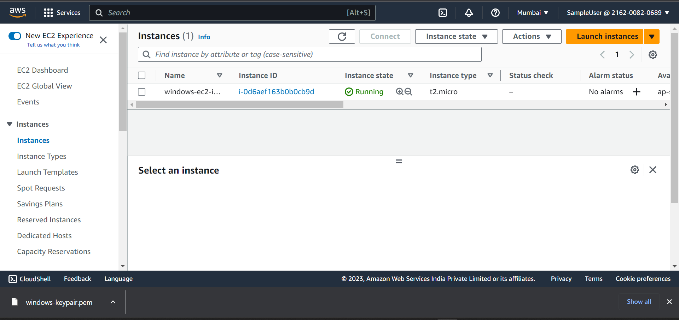

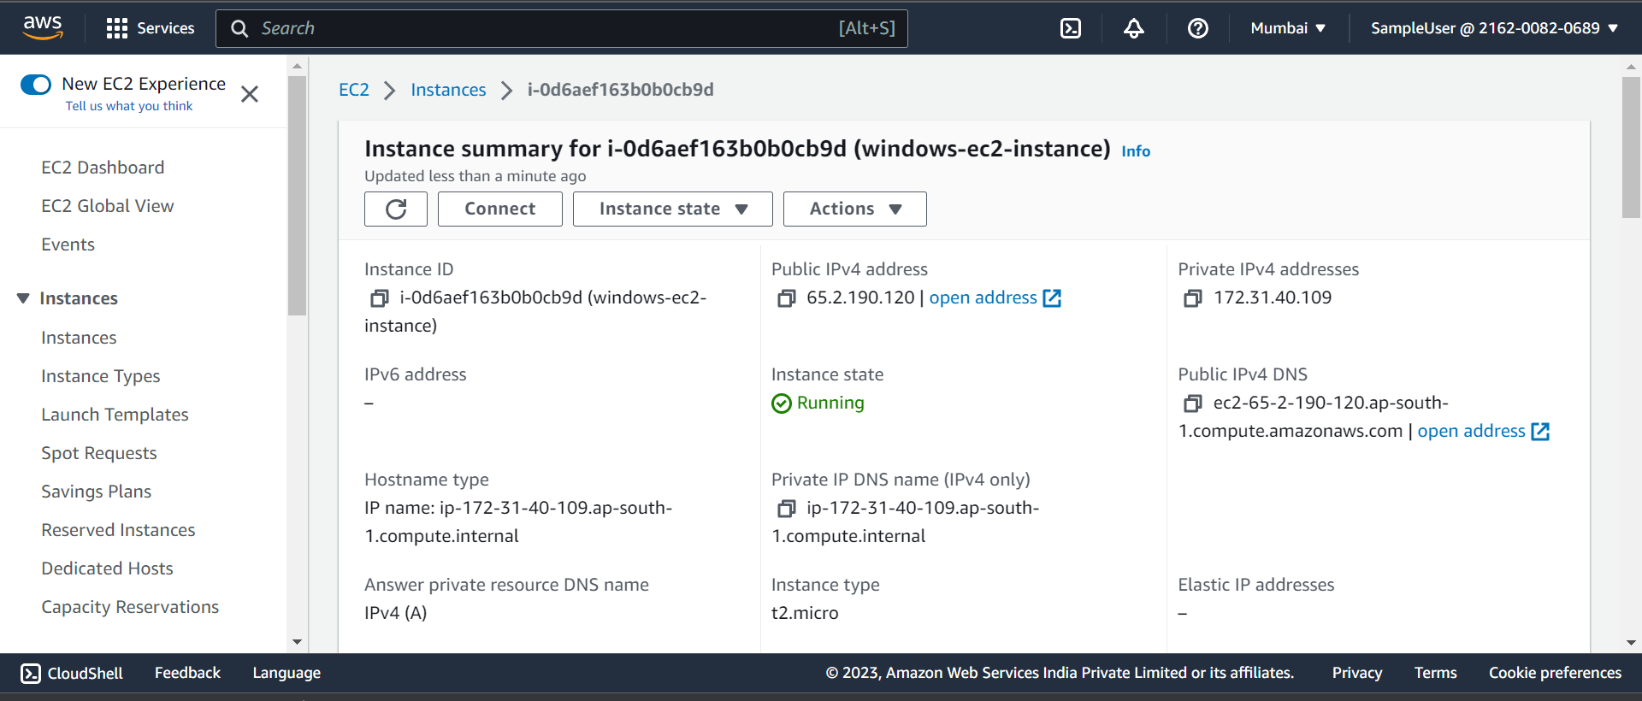Copy the public IP address

65.2.190.120

Click on connect

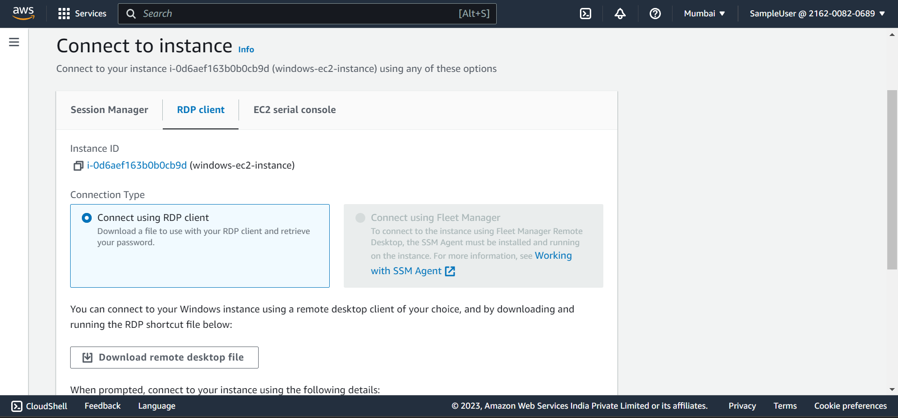

Copy username ::: by default it is **Administrator**

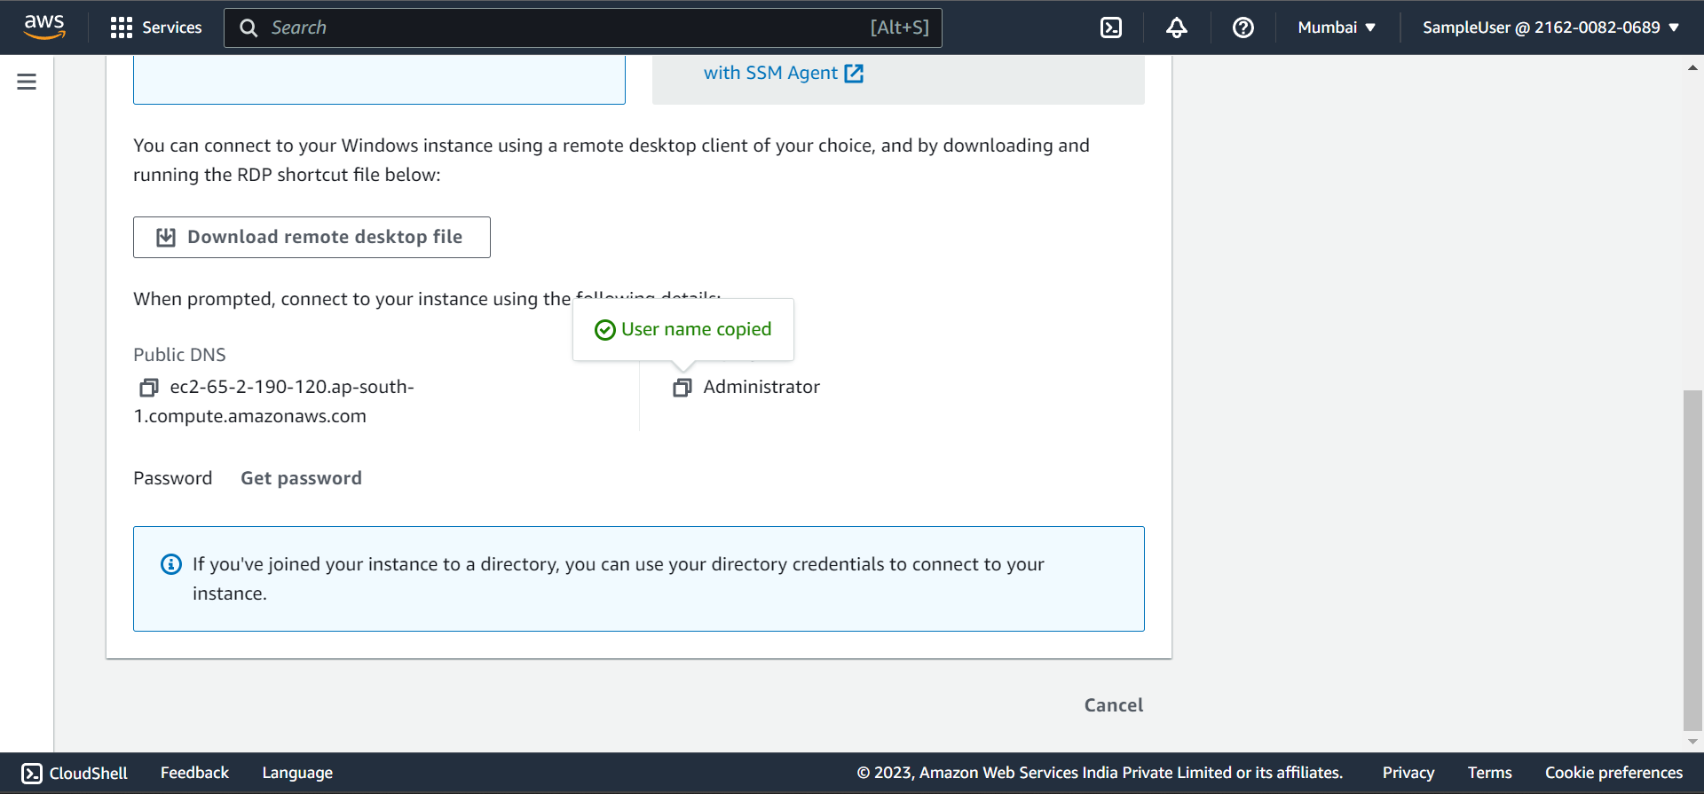

Click on get password and upload keypair file then a password will get generated.

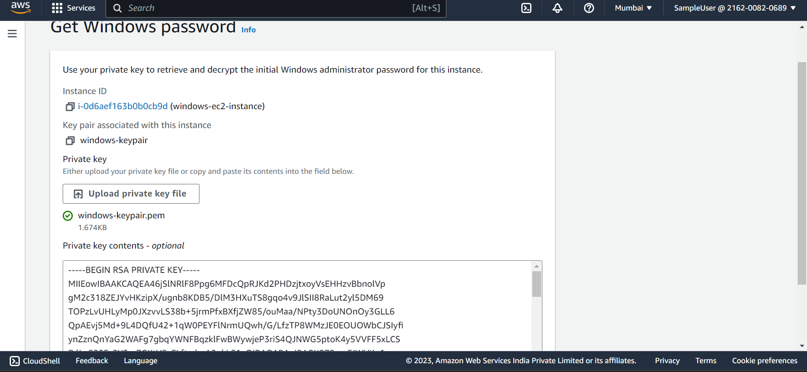

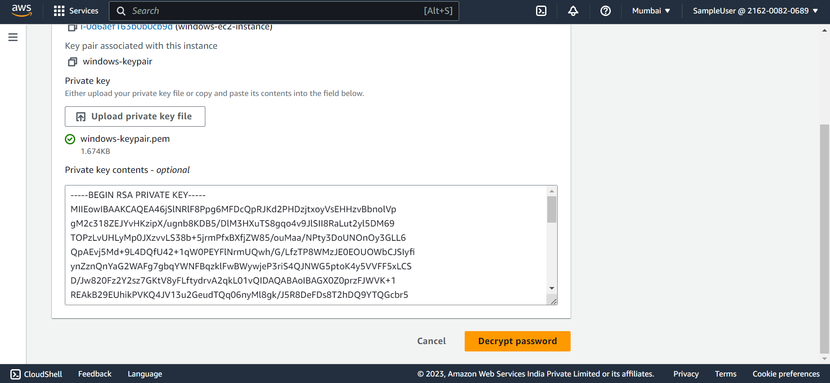

Click on Decrypt Password. Then a password is generated. Copy it.

Password : ut&fFFLDzzI?(gS2;xa5SvaJ.1?a.?vy

Now open your RDP (Remote desktop protocal) from your local machine

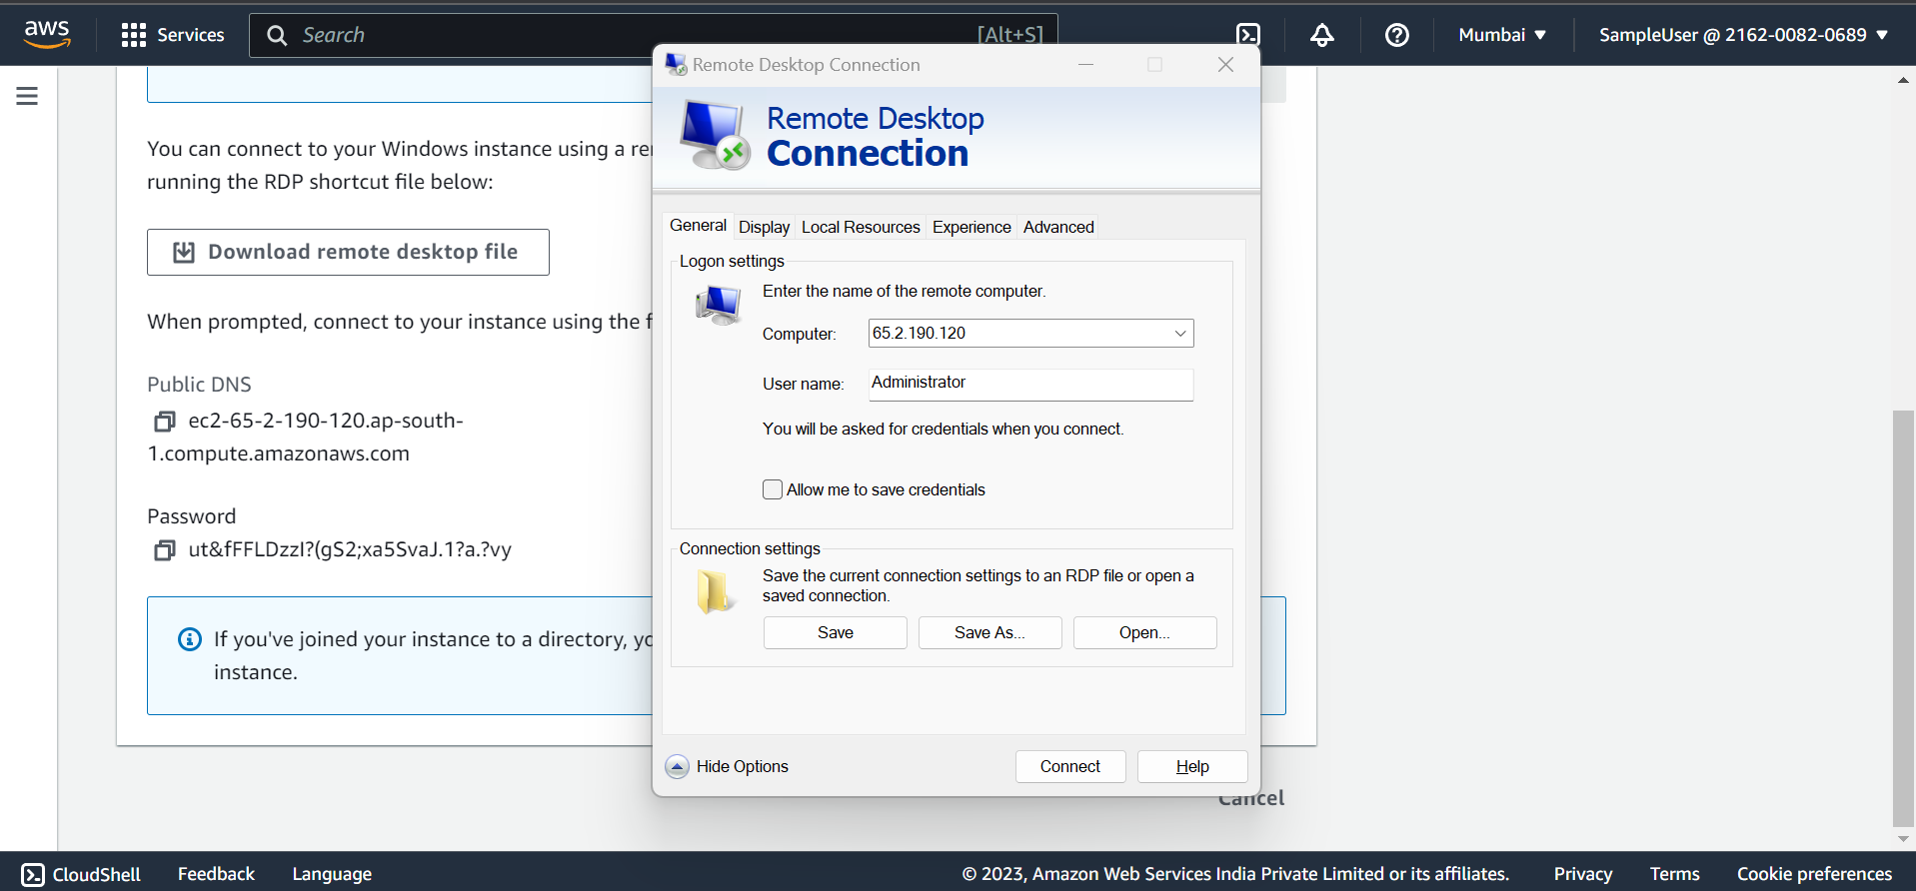

Enter IP address, Username and click on Connect and enter password.

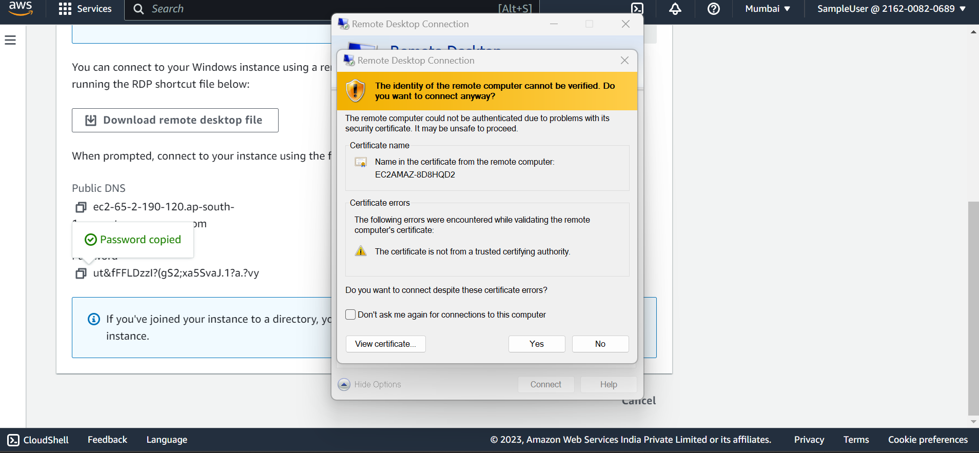

Verify Certificate click on Yes.

Now you can able to connect to windows Ec2 machine.

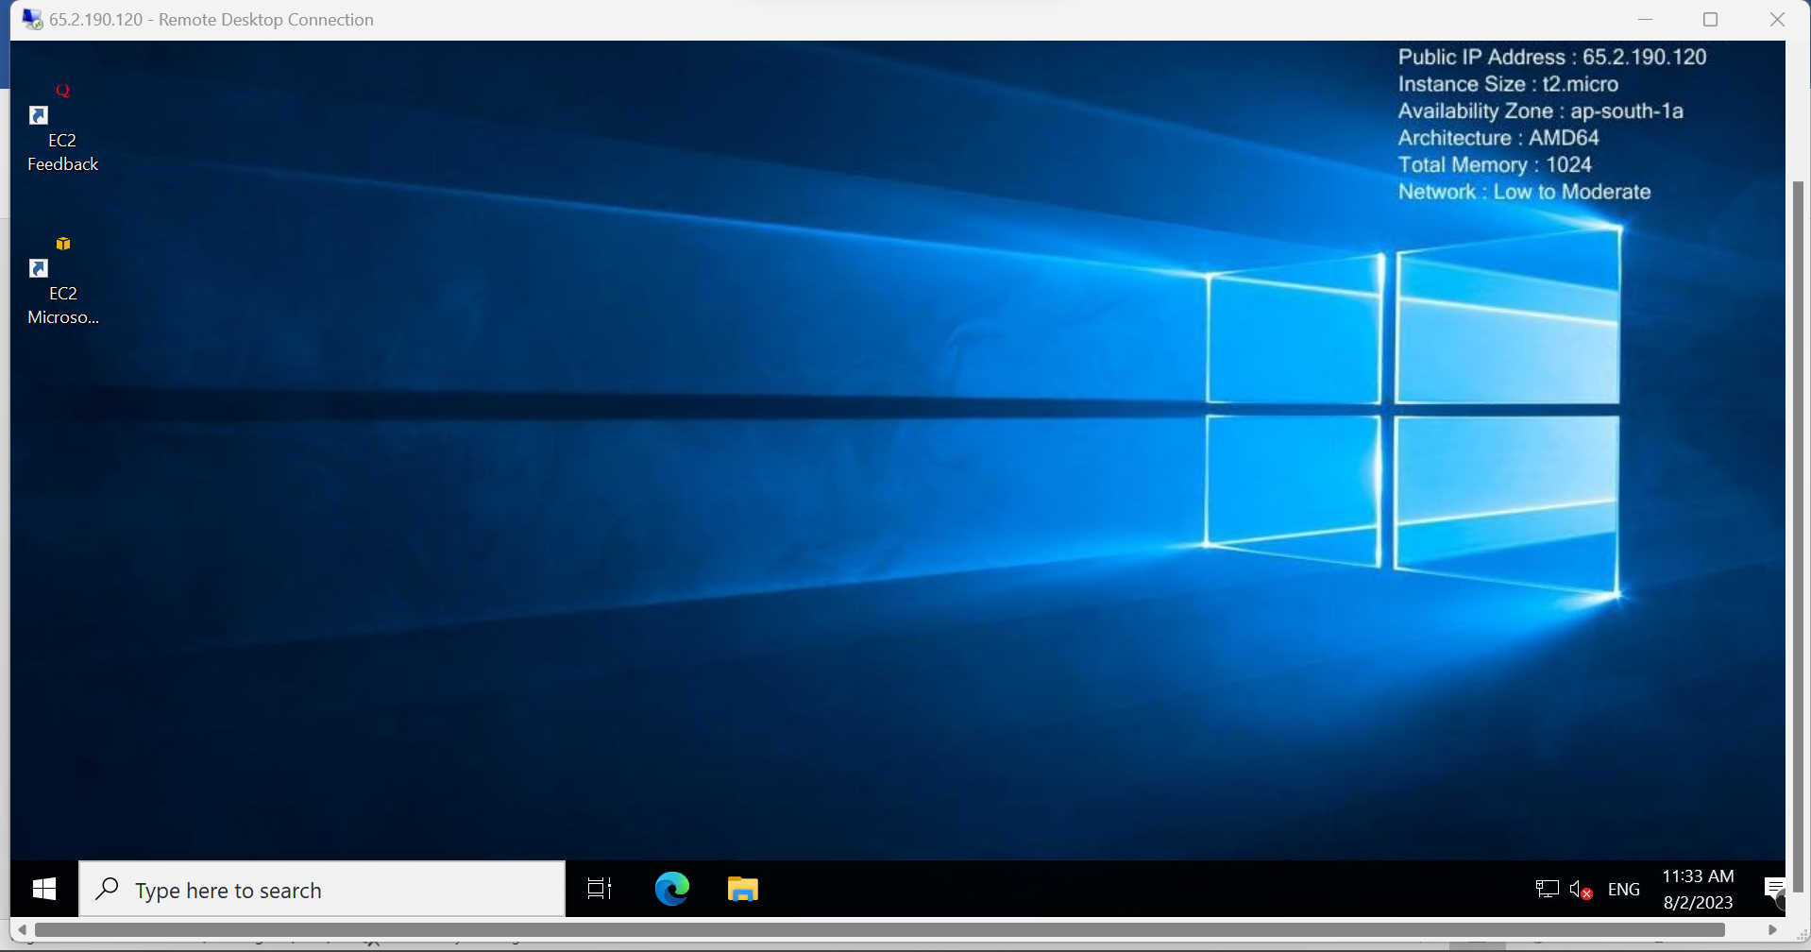

**RDS (Relational Database Service):**

Amazon RDS is a database service provided by AWS. RDS makes easier to setup databases on cloud.

RDS is known as managed relation database service.

**Why RDS ?**

To Install any DB engine , we need 3 things.

1. Server
2. OS
3. DB

For on-premise , User needs to take care of Server, OS related problems and updates, and on top of OS install DB.

In AWS EC2 , vm is managed by AWS and os, DB is managed by User.

For RDS, everything is managed by AWS.

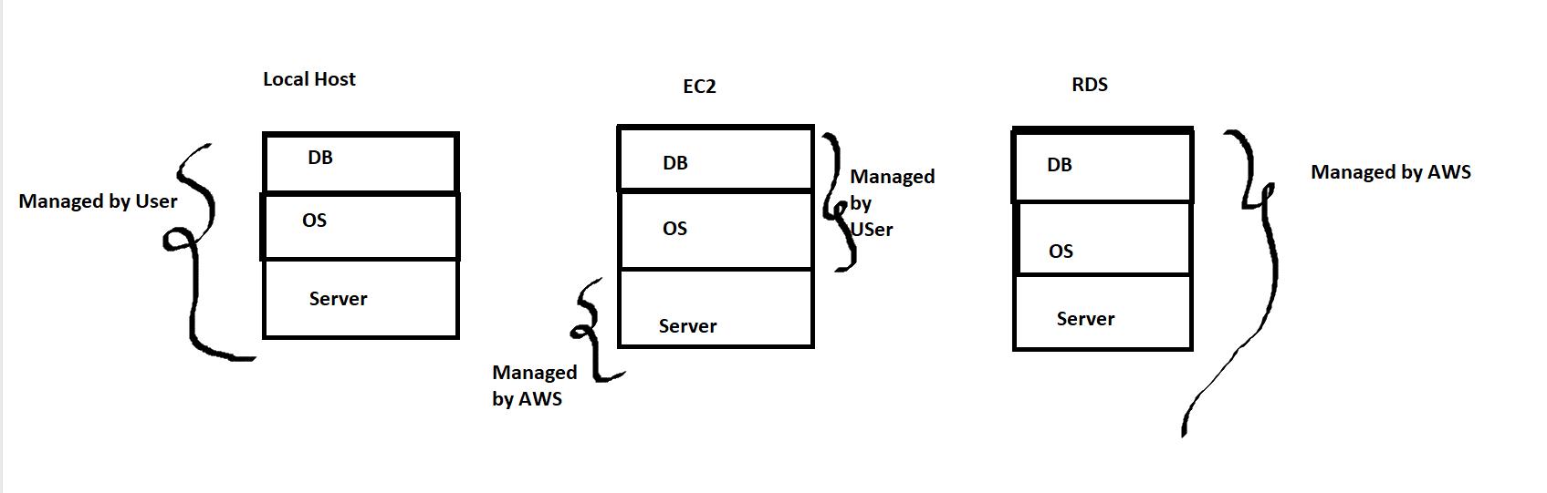

**Types of DB engines in AWS:**

1. Postgresql
2. MYSQL
3. SQLServer
4. MariaDB
5. Amazon Aurora
6. Oracle

**Creating an DB instance:**

1. Login to AWS console.
2. Search for RDS and click on it.
3. Click on Create database
4. There are two types of creation methods.
5. Standard Create
6. Easy Create

In Standard create, you have to set some configuration like Security, Availablity and backup.

In easy create, there wil be some default configuration settings provided by AWS.

1. Select Engine Type like Postgresql, MYSQL
2. Select DB instance size.
3. Production
4. Dev/Test
5. Free tier
6. You can enter username & password.

Here you can enter a specific password or AWS will generate a specific password for you.

1. Click on create database.
2. Now your database is created successfully.

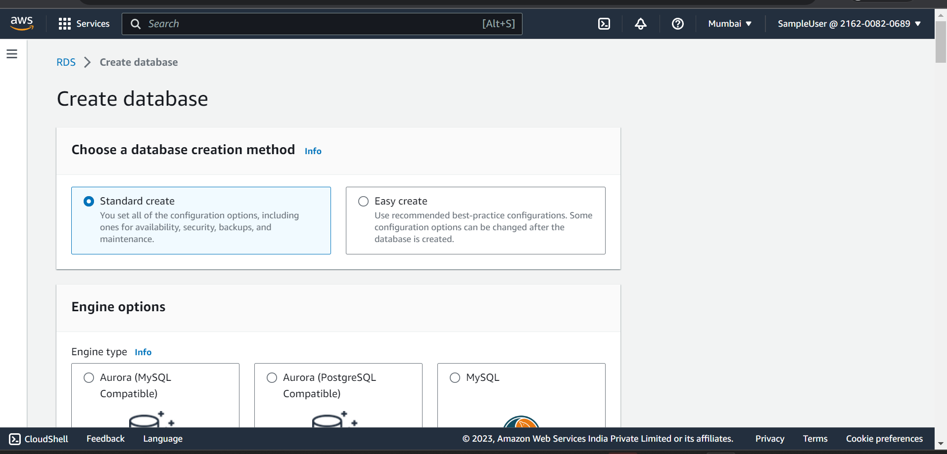

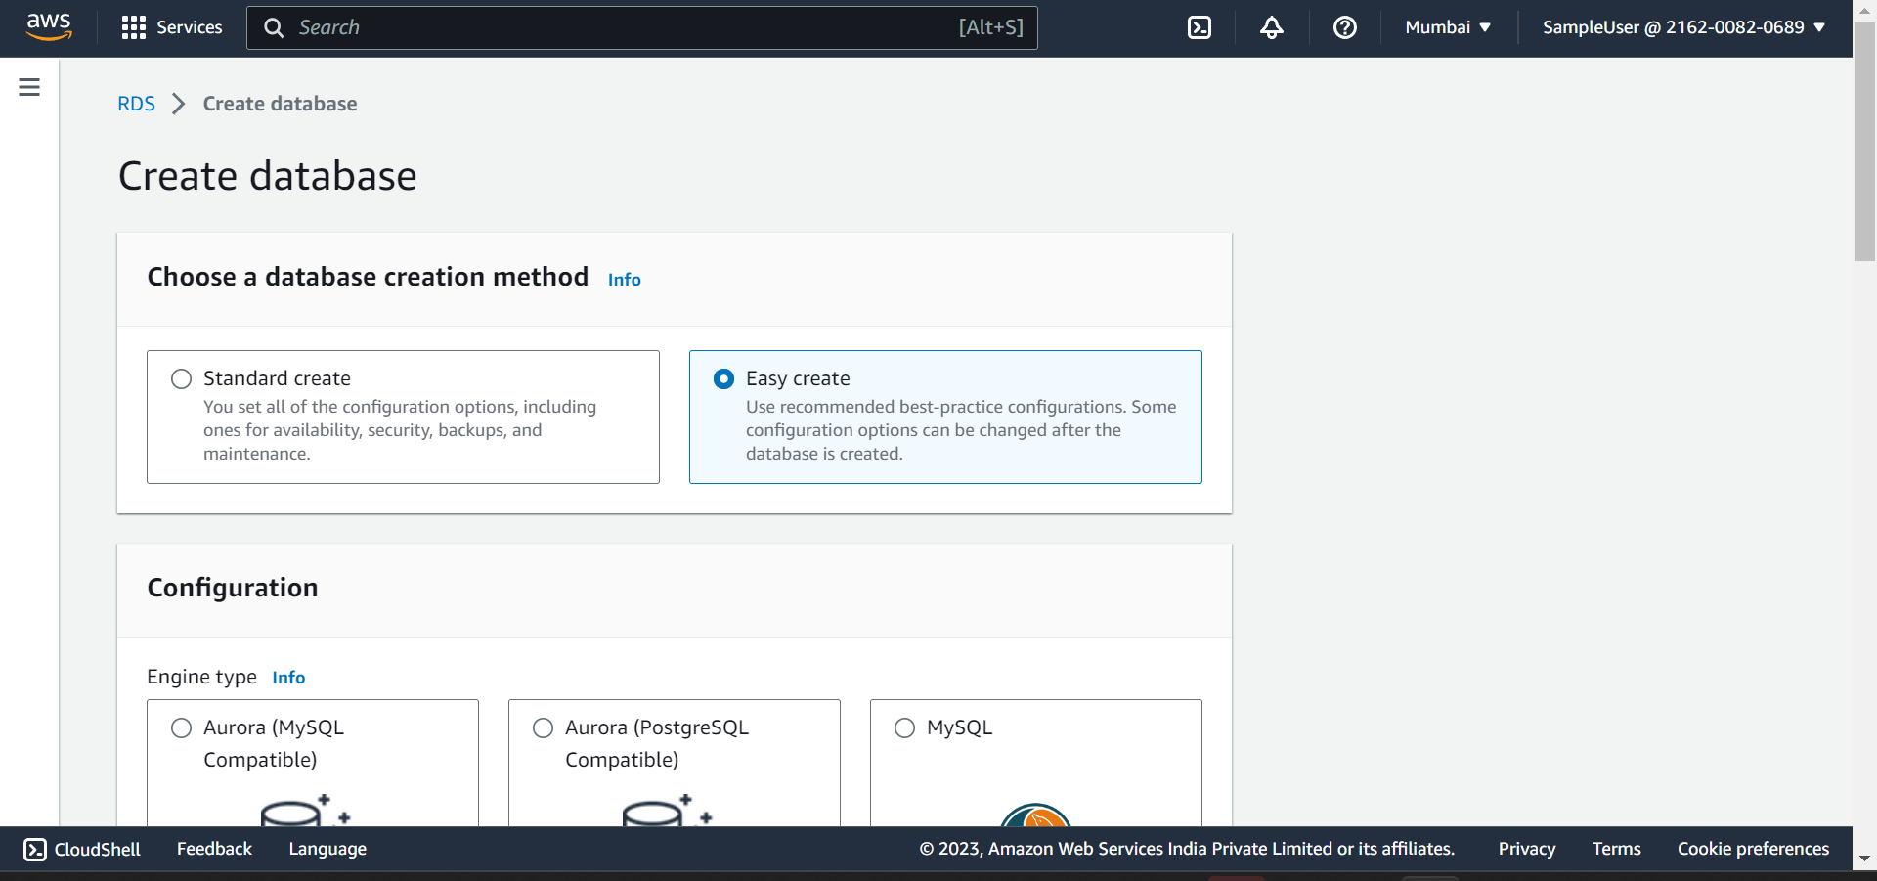



1. 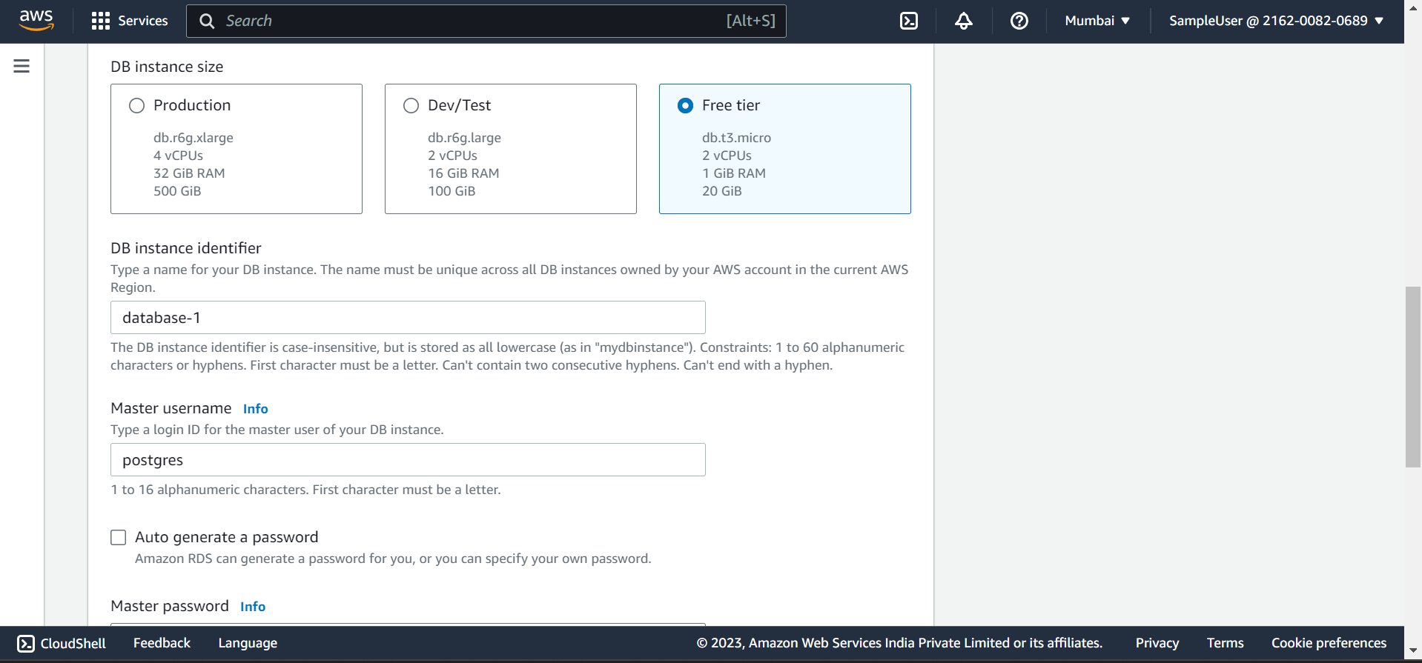
2. Password : Harish1234
3. 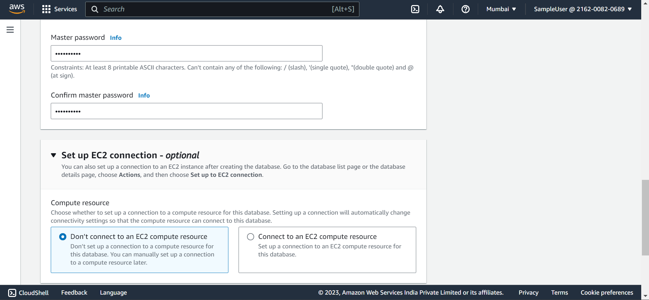
4. 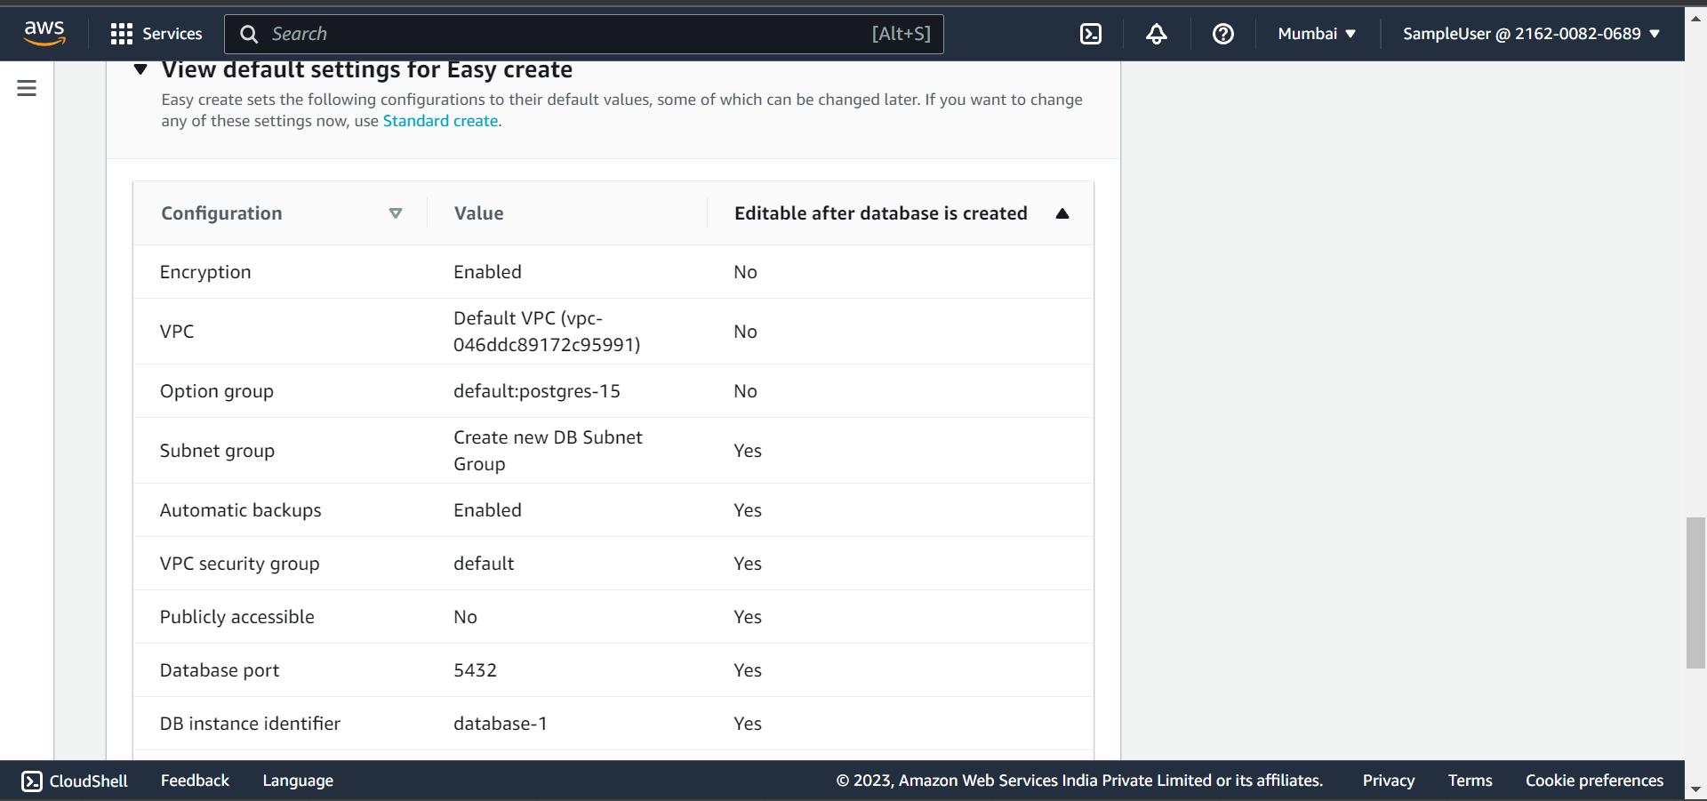

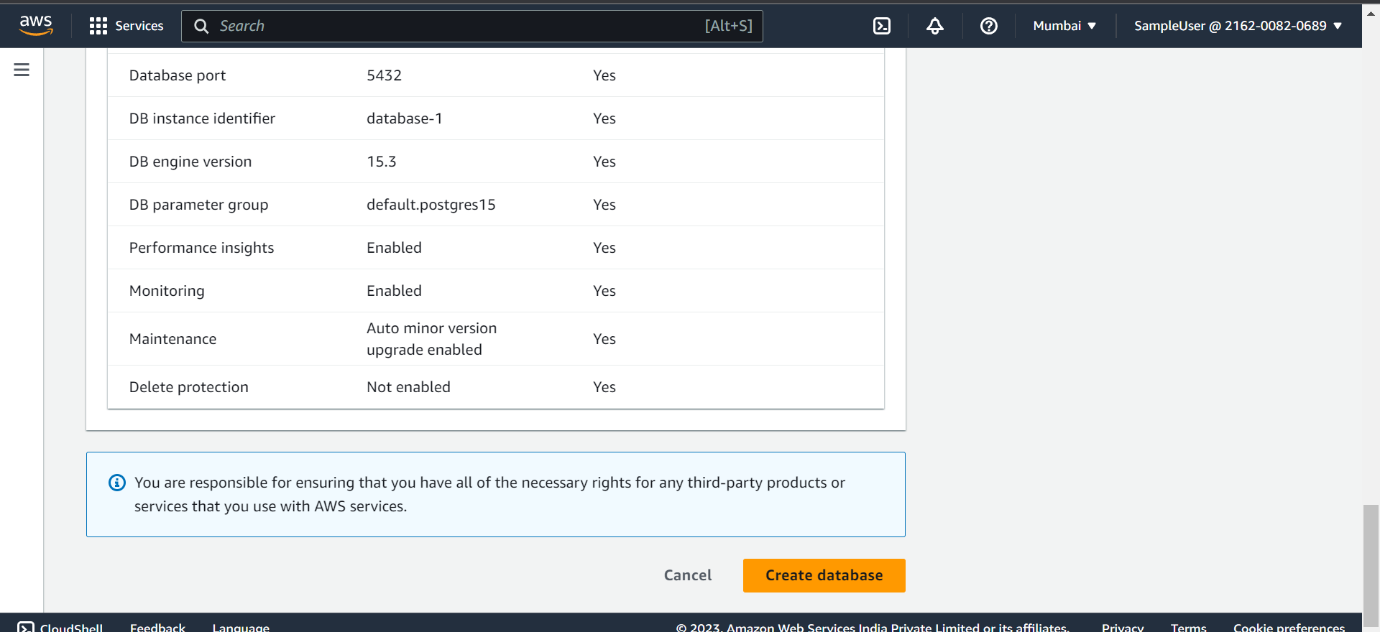

1. Click on create database

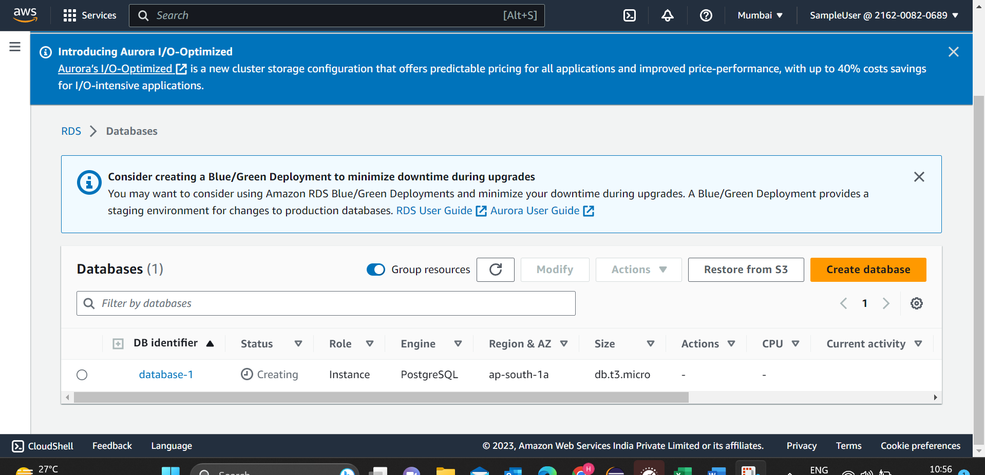

Here the status is still in creating , wait until it changes to Available.

After status changed to Available.

**Connecting to RDS using Amazon Linux EC2**

**Steps:**

1. Connect to your EC2 instance.
2. Install postgresql15

sudo dnf install postgresql15

1. Create a Database and connect to it.

Using following commands:

createdb -h database-1.cbbomg10t5o0.ap-south-1.rds.amazonaws.com -p 5432 -U postgres MYDB

psql -h database-1.cbbomg10t5o0.ap-south-1.rds.amazonaws.com -p 5432 -U postgres MYDB

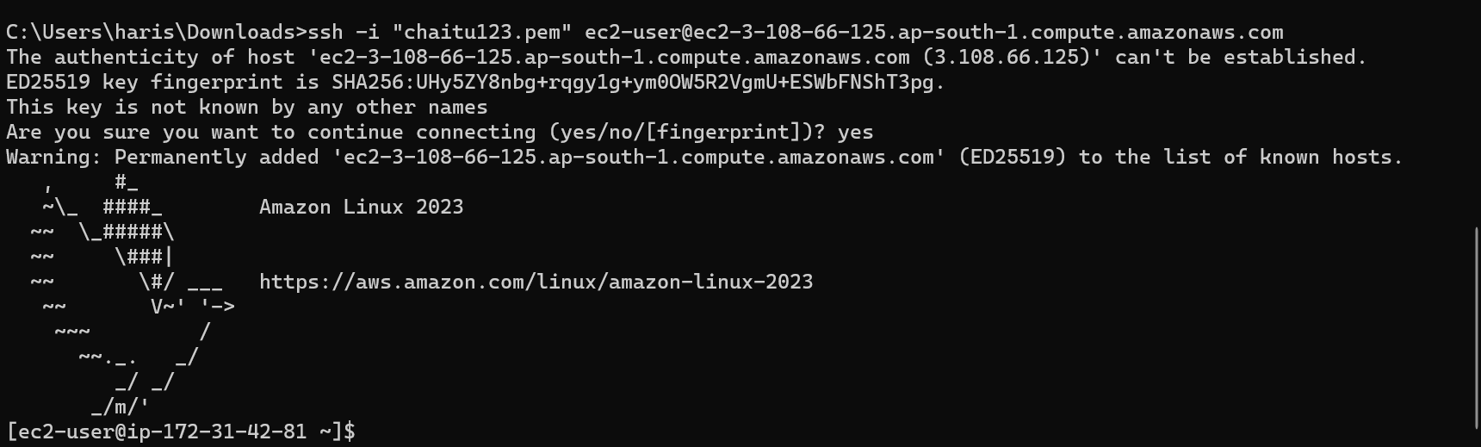

Now we have connected to EC2

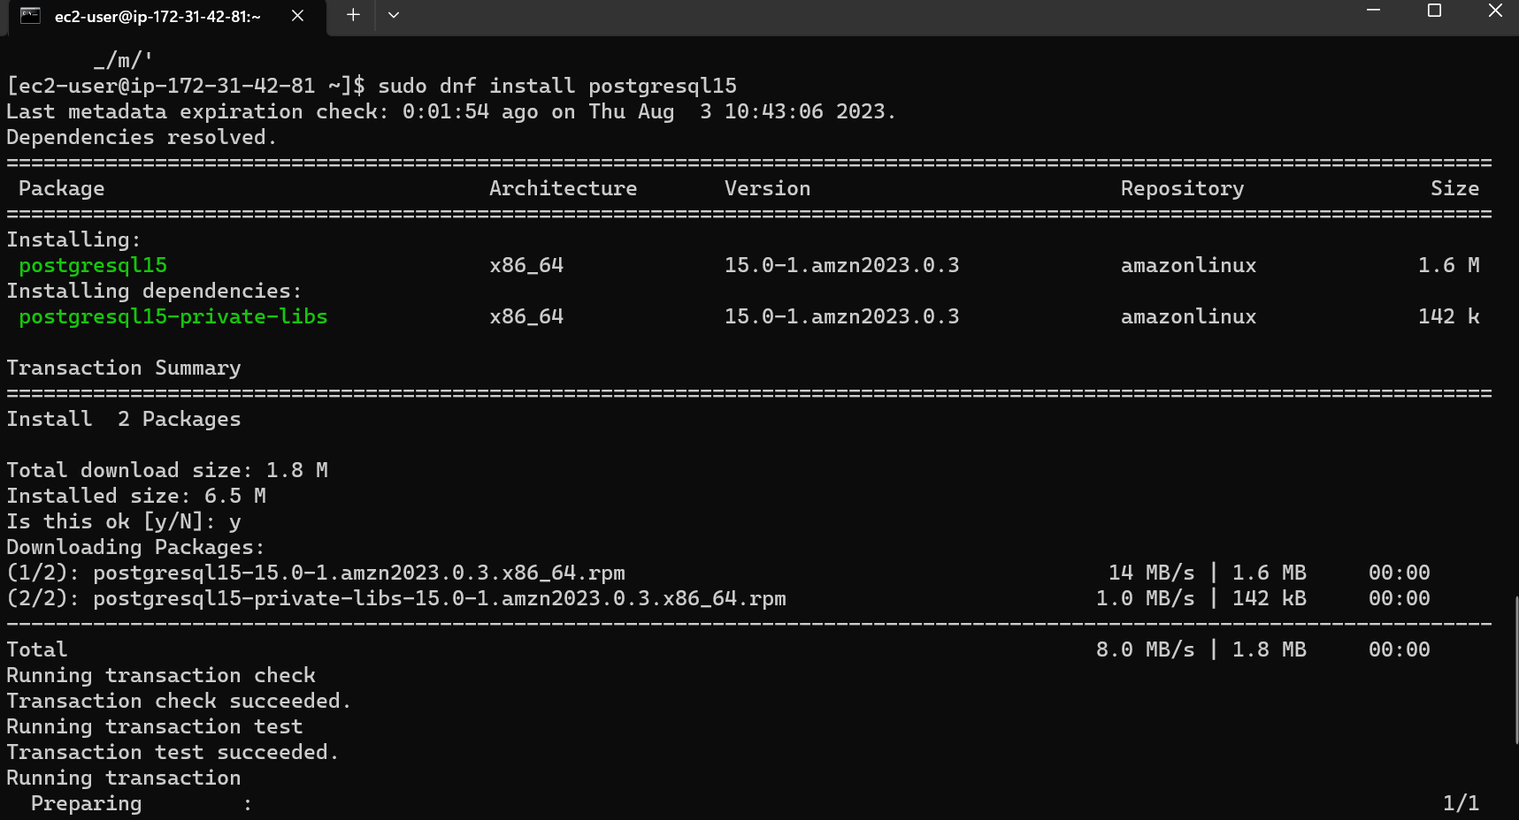

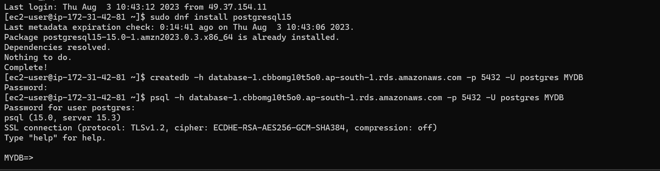

Now you have successfully connected to Database.

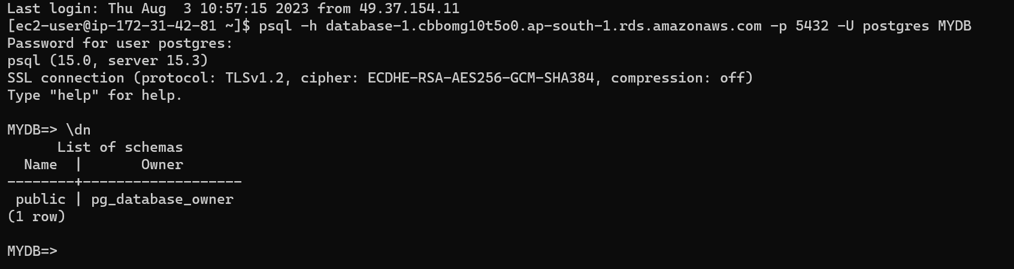

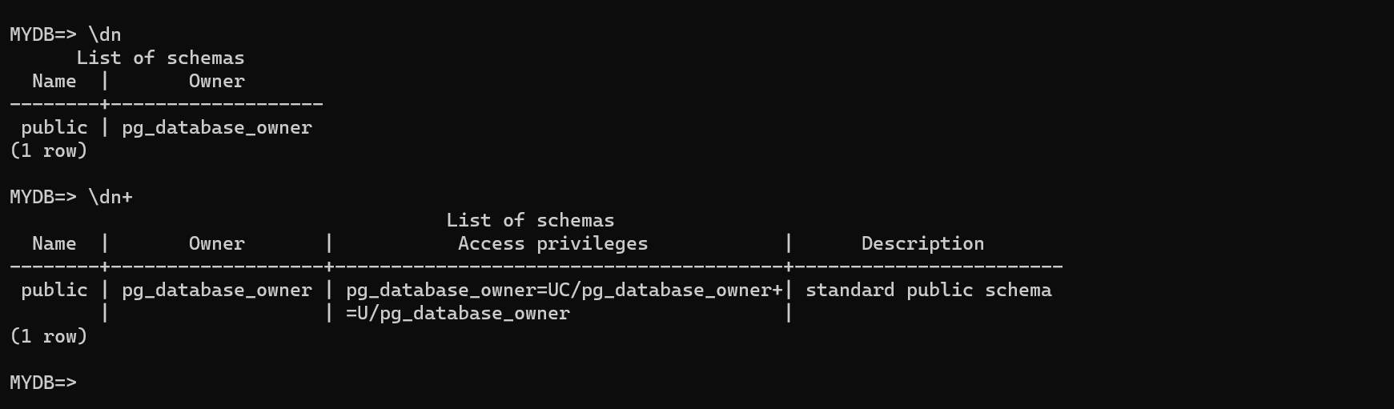

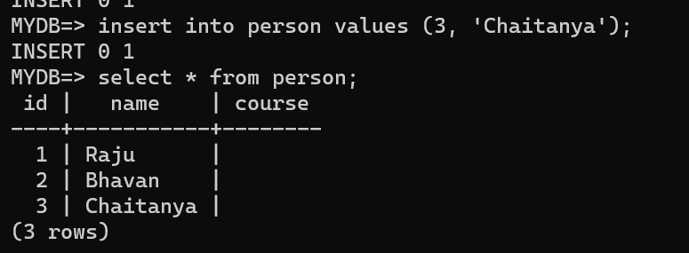

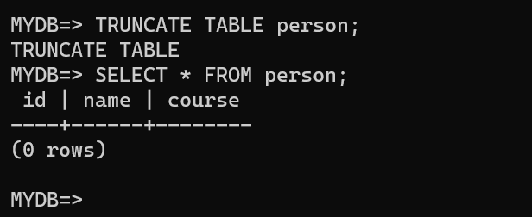

**Deleting DB instance:**

1. Select the db instance which you want to delete.
2. Click on actions
3. Click on delete.

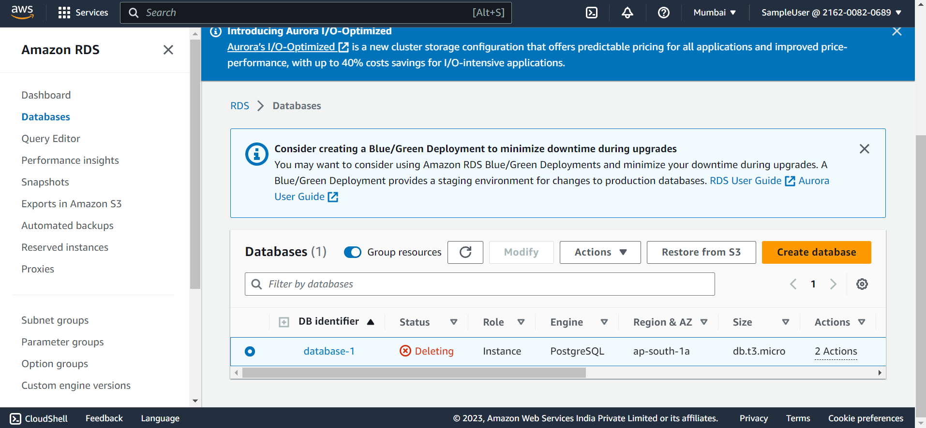

**IAM (Identity Access Management):**

IAM is a service which is used to access AWS services and resources. IAM is completely free for life time.

In IAM,

**Identity:** Authentication

**Access:** Authorization

* Authentication is just for sign in to AWS account.
* Authorization is providing access (permissions) to a particular service.

Using IAM we can also place “Multi-factor Authentication [MFA]” for the root user.

**In AWS we have 2 types of Users.**

1. **Root User:** The user who created AWS account and has access on all 200+ services
2. **IAM User:** IAM user is created by root user. IAM user can able to sign in to AWS account. But don’t have access/ permissions to use any service.

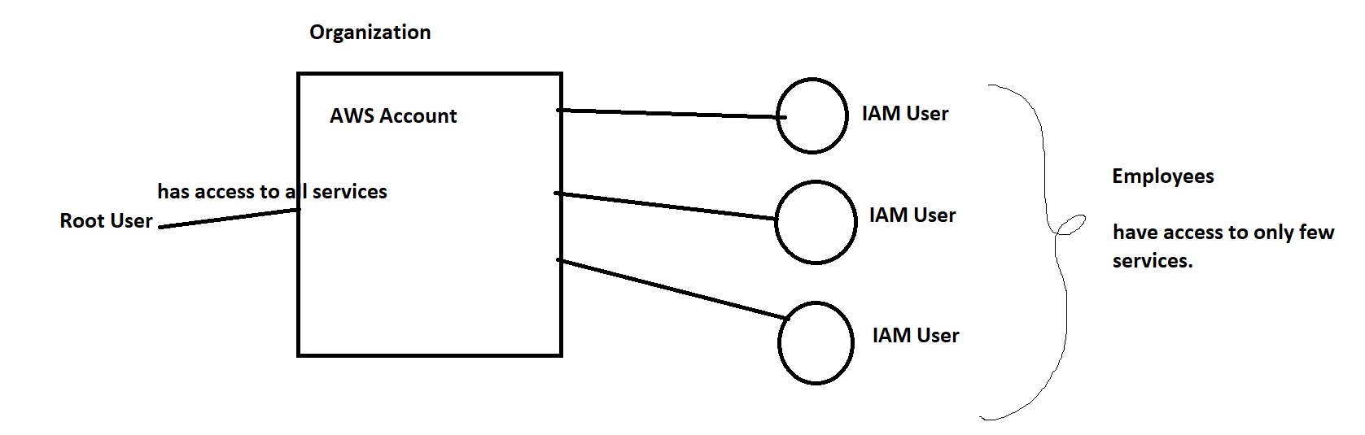

Here, DB team has access to only few services, DevOps team has access to only DevOps

**Sub services in IAM:**

1. Users
2. Policies
3. Groups
4. Role

**IAM user:**

* IAM user is a user who is created by root user to access only specific services from the AWS account.
* He/ She don’t have permissions to all the services, these permissions are provided by the root user.
* We can provide 2 types of access to the IAM user.

1. AWS console access
2. Programmatical access

**IAM Policies:**

* IAM Policy means set of permissions that are added to a particular IAM user or Group.
* If you are an IAM User, you can able to login but don’t have access to any service to access any service attach policies for IAM user then only he/she can access the service.
* There are 2 types of IAM Policies

1. AWS managed: by default created by AWS.

Ex: AdminFullAccess , S3FullAccess, S3ReadOnly etc

1. Customer managed policies:

Some policies are attached by customers.

1. Inline Policies

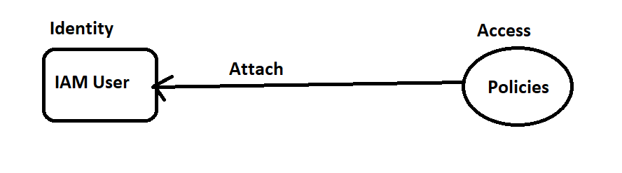

**IAM Groups:**

Suppose I want to assign same policies to a particular group of people (IAM users). Then I can create a IAM group and attach the policies to that group and add IAM users to that group.

So, that I can attach the policy at once and it reflects to all the users in that IAM group.

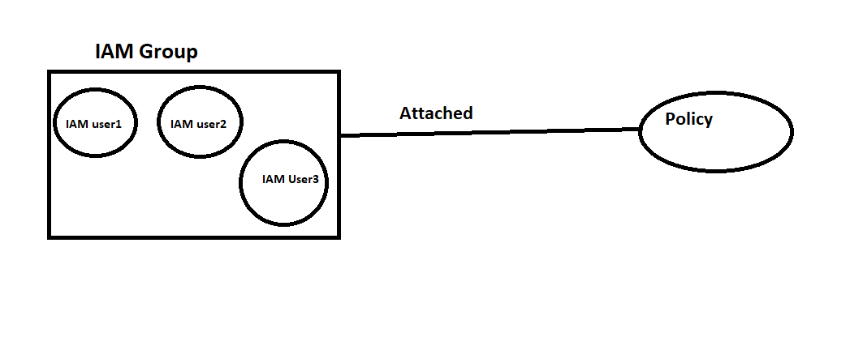

**IAM Role:**

Suppose, I want to provide temporary access to any service which can be automatically expired after 1 hour then I should create a IAM Role.

IAM role doesn’t have access to AWS console. It has only access key and secret key when you want to perform a task.

**Creating an IAM User and adding policies:**

If you are a root user then you have access to IAM. Or if you are an IAM user then you need to get IAM full access to create IAM user.

Steps:

1. Login to AWS console.
2. Search for IAM
3. Navigate to IAM dashboard
4. Select users in the access management from left panel
5. You can see existing IAM users if created.
6. Click on Add users
7. You can provide 2 types of access.
8. AWS Console access
9. Programmatical access
10. Select AWS console access and select I want to create an IAM user
11. Here, you can choose an autogenerated password or create a custom password.
12. Click on Next

For programmatical access we need to provide access keys and secret keys so that he/ she can access the services programmatically.

1. We can add permissions. We have 3 options for adding permissions.
2. Add a user to group
3. Copy permissions
4. Attach policies directly
5. Select a permission and click on add permission.
6. Now click on create user.
7. Click create an IAM user with some permissions
8. Click on Download.csv file which will download login credentials.

Now you can login using IAM User.

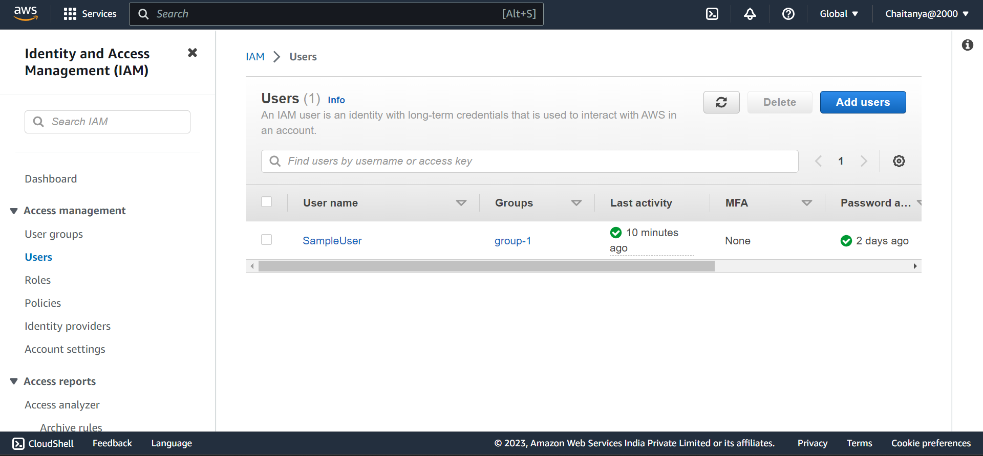

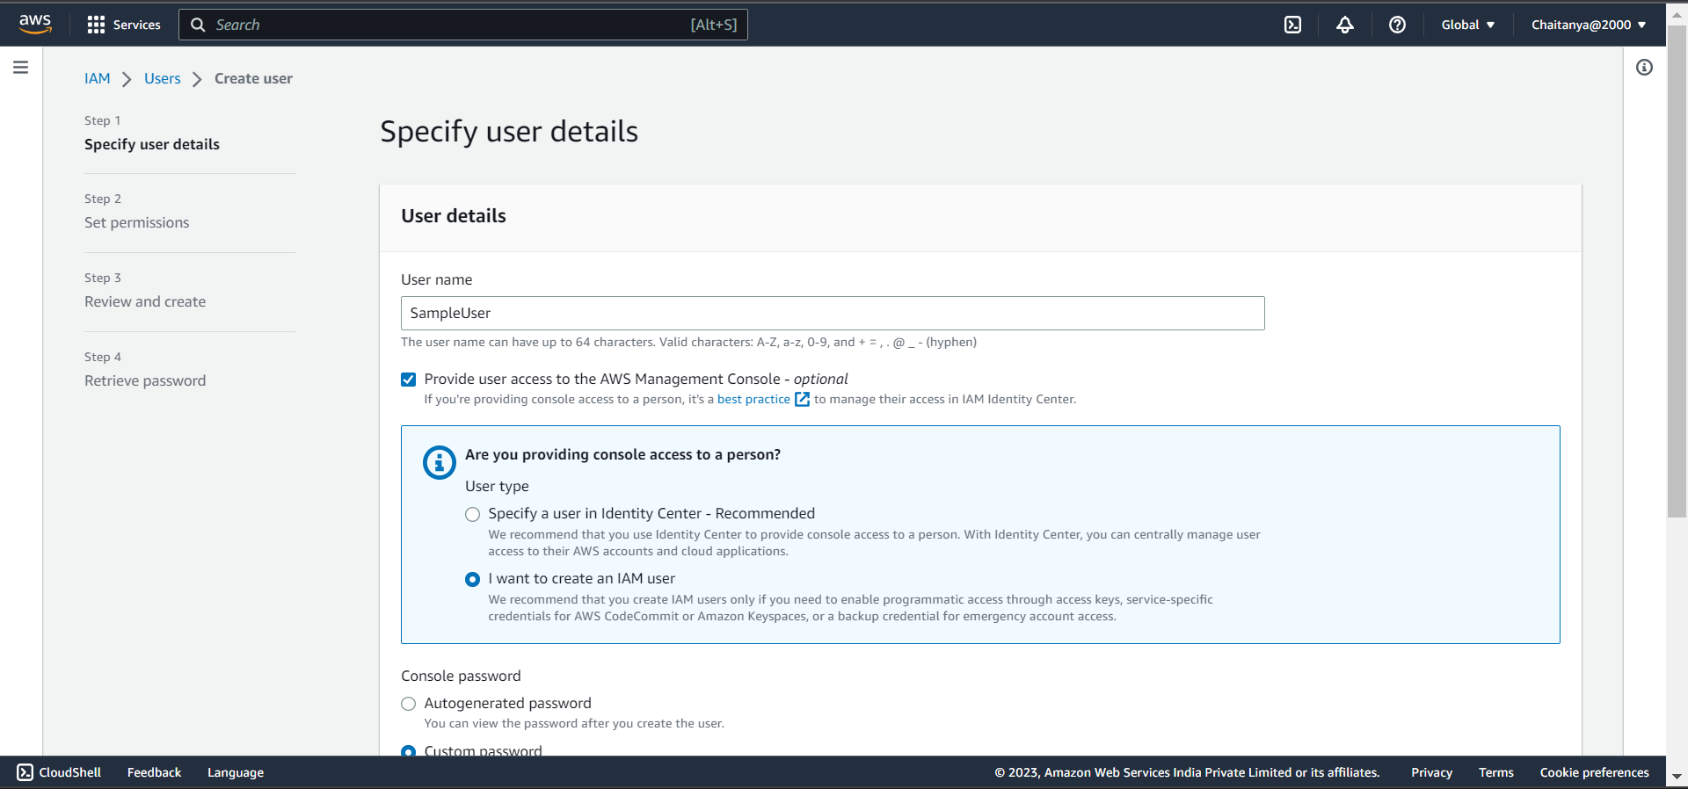

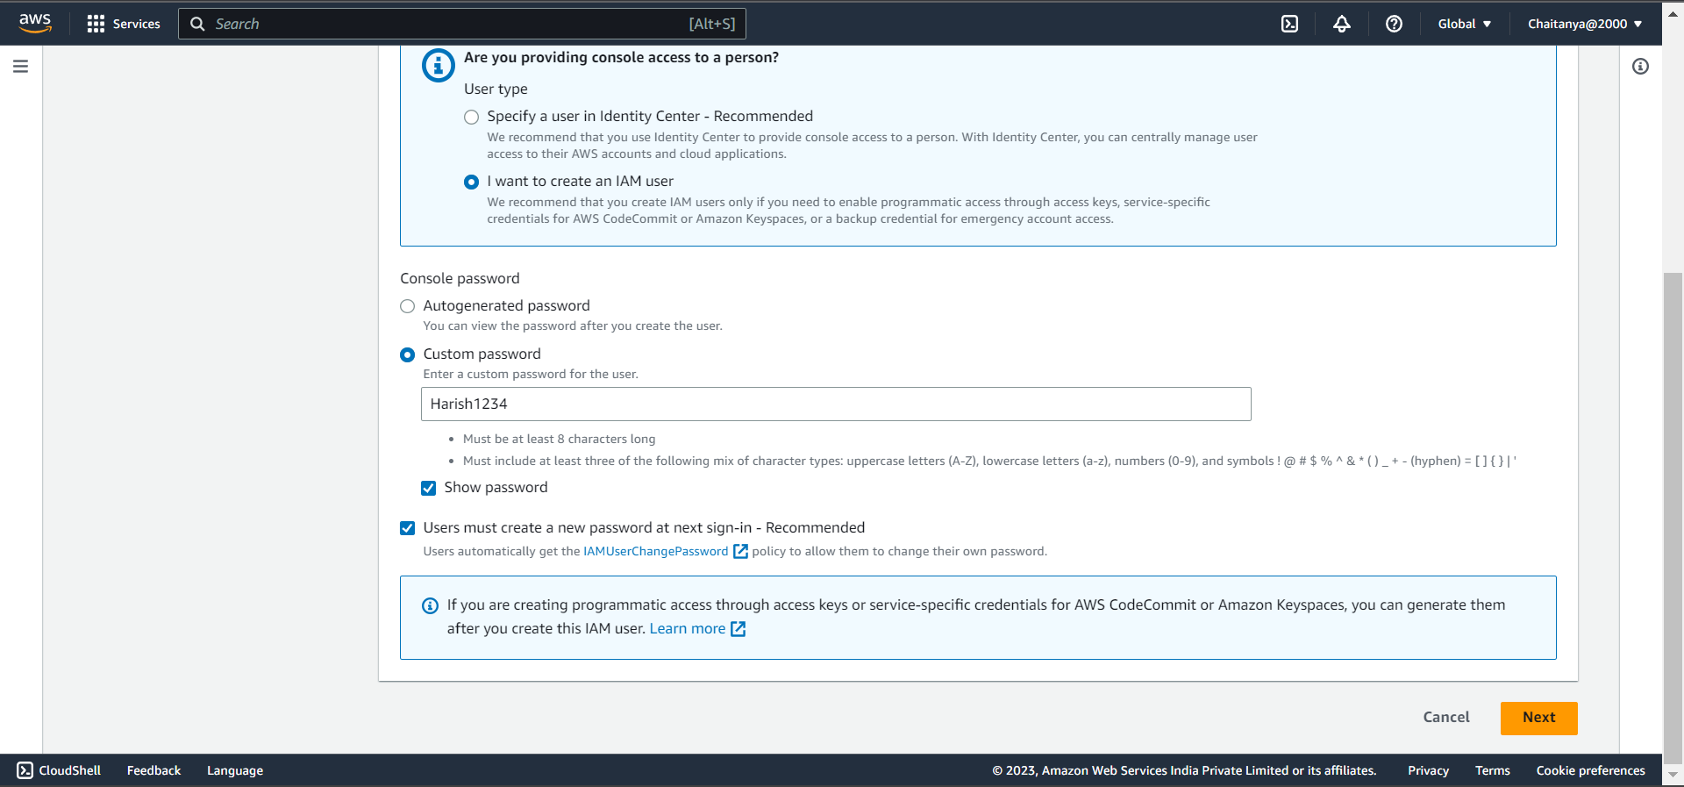

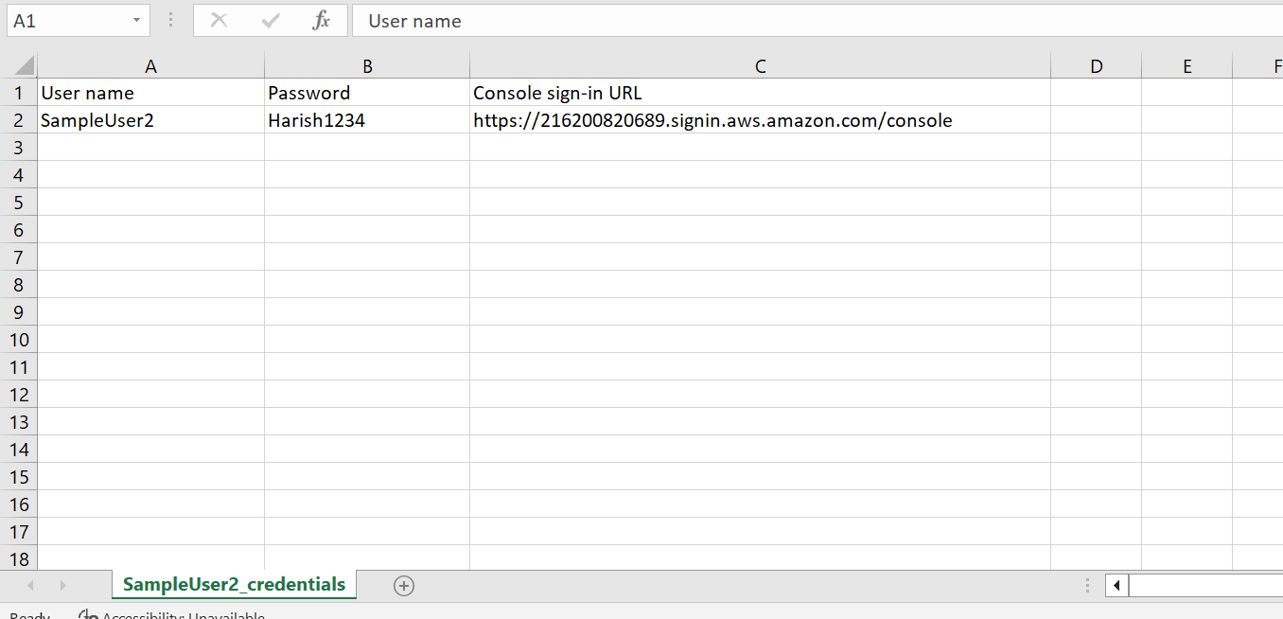

**Creating Groups:**

1. Navigate to IAM dashboard and select User groups from access management.
2. Enter group name
3. Select users to add
4. Attach policies
5. Click on create group
6. Now a new group is created.
7. 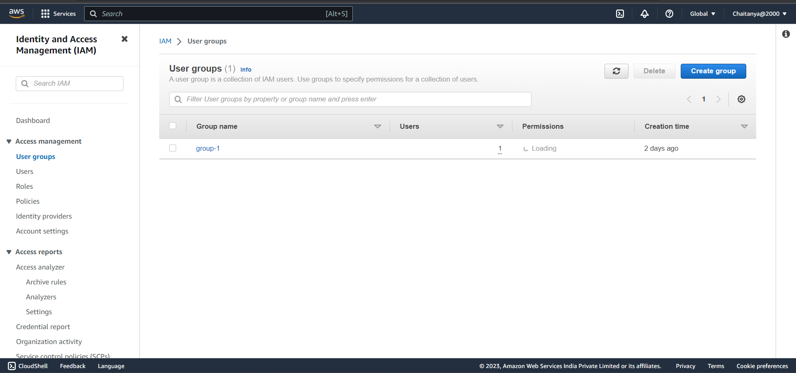
8. 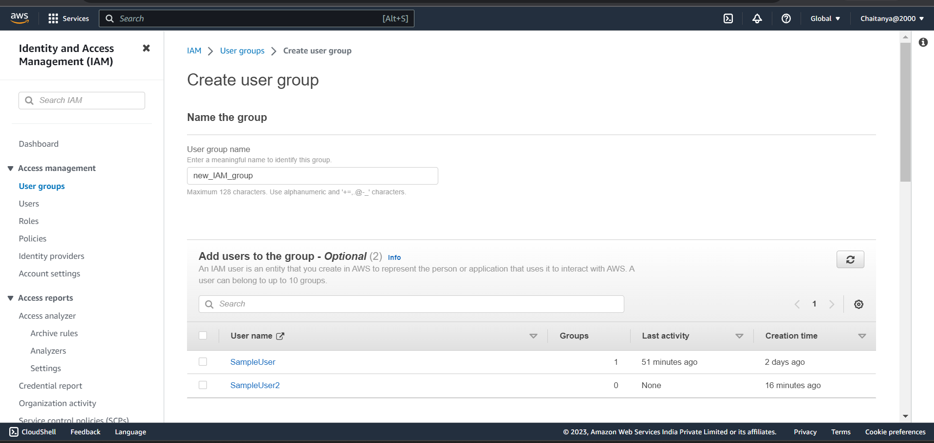
9. 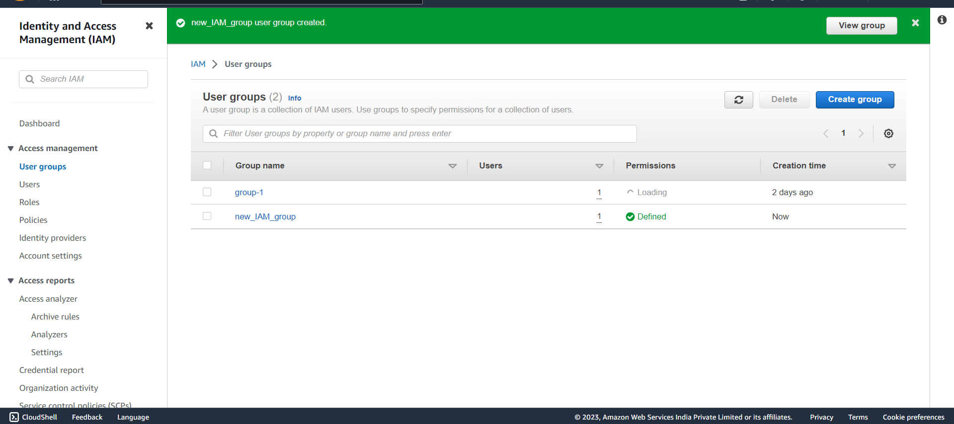
10. 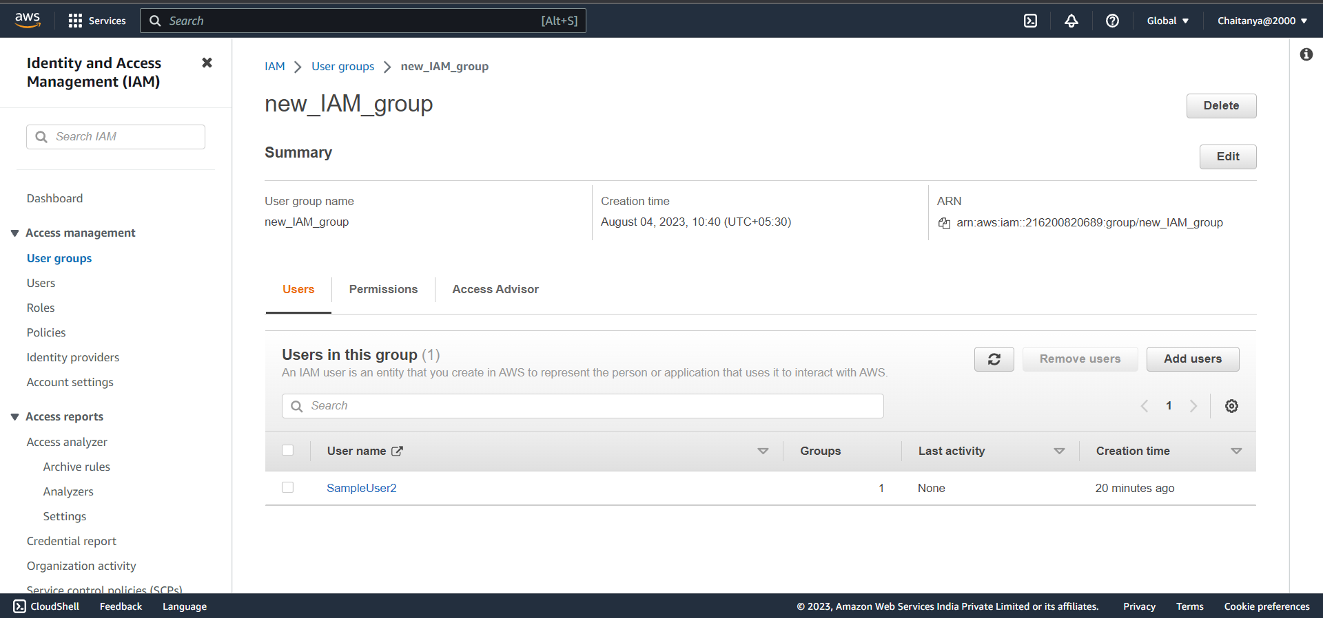

**DMS (Data migration Service):**

DMS is a migration service provided by AWS to migrate databases, data from one database to another database or one database to another storage location (S3 bucket).

DMS helps to migrate your databases to AWS using simple user interface.

It helps to migrate your database to aws cloud quickly and securely. Low cost and minimum downtime.

DMS supports 2 types of migrations.

1. Homogenous support
2. Heterogenous support
3. Homogenous: Homogenous means data migrated between same or very similar database platforms. (eg: MYSQL to MYSQL, MYSQL to mariadb)
4. Heterogenous: Heterogenous means data migrated between different database engines (eg: MYSQL to Postgres).

AWS DMS supports a variety of different data stores,

1. Relational databases (such as Amazon Aurora, MySQL, MariaDB, Microsoft SQL Server, Oracle, and PostgreSQL)
2. Non-relational databases (such as MongoDB and Amazon DynamoDB).

**Creating a Replication Instance:**

Replication instance is used to run your migration tasks.

Steps:

1. Click on create replication instance.
2. Enter instance name ( this name should be unique in the aws region and should not start with numbers)